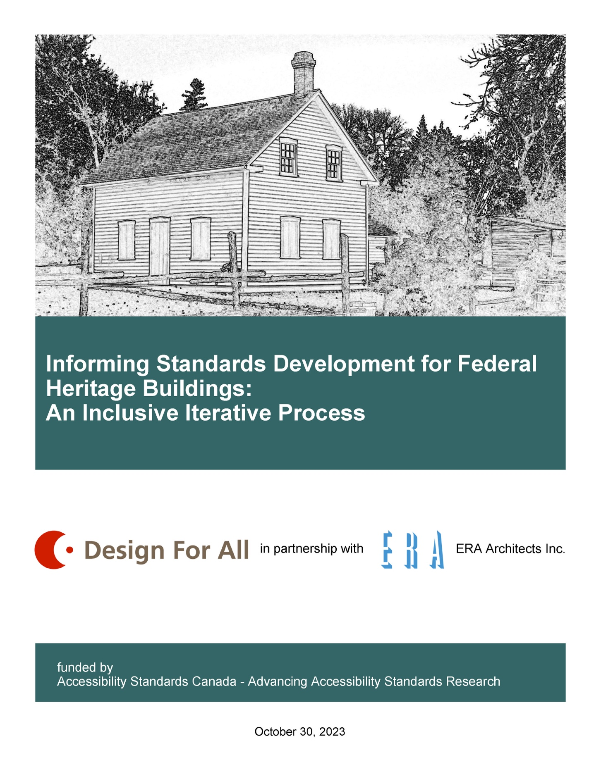

Informing Standards Development for Federal Heritage Buildings: An Inclusive Iterative Process

Date: October 30, 2023
Copyright: © Design For All Inc. 2023
Information: Design For All in partnership with ERA Architects Inc. Funded by Accessibility Standards Canada – Advancing Accessibility Standards Research.

Table of Contents

Table of Contents 2
Dedication 3
Land Acknowledgement 3
Partners and Collaborators 3
Definitions 7
Introduction 9
Reality of Existing Accessibility at Federal Heritage Sites 11
Iterative Process (Iterative Model of Inclusive Decision-Making) 20
Informing Standards for Federal Heritage Building Accessibility 36
The Model for Informing Accessibility Standards as they Apply to Federal Heritage Buildings 46
Iterative Model of Inclusive Decision-Making (IMIDM) for Federal Heritage Buildings 50
Iterative Model of Inclusive Decision-Making (IMIDM) in Images 56
Recommendations Supporting the IMIDM Process 63
Appendix A: Analysis National Energy Code and National Fire Code 73
Bibliography 78

Dedication
This research report is dedicated, in memory of our friend, and champion of the disability movement, John Rae. John’s passion for disability issues and his love for visiting heritage sites created a desire to ensure everyone had the ability to experience Canadian history firsthand. He was the inspiration for the development of this project.

Please note - The formatting of the text in this report has been simplified for purposes of readability by a wide range of people.

Land Acknowledgement
Design For All Inc. is an accessibility design consulting firm located in Winnipeg and we acknowledge that the land on which we are located is on Treaty 1 Territory, Traditional Territory of Anishinaabeg, Cree, Oji-Cree, Dakota, Dene, and homeland of the Métis Nation and we acknowledge that Winnipeg's water is sourced from Shoal Lake 40 First Nation in Treaty 3 Territory. We respect these Treaties and all the various treaties across Canada.

Partners and Collaborators

Design For All Inc.
Judy Redmond and Brian Everton - Design For All Inc.
Design For All Inc. is a professional design consulting firm that specializes in the areas of accessibility, Universal Design, and sustainable design. Design For All Inc. was started in 2004 by Brian Everton, a Professional Interior Designer who has also completed studies in industrial design and business management. Mr. Everton has specialized in the areas of functional design for products and the built environment with respect to the issues of disabilities, aging and universal design for over 25 years.
In 2021, Judy Redmond BA MSc, a specialist in disability and accessibility issues, and the implementation of accessibility policy and legislation, joined the firm. Ms. Redmond has worked in inclusive design within government for 22 years. A Master of Science degree with distinction in Accessibility and Inclusive Design compliments her practical experience. Community participatory process and inclusive design are carried forward in her approach for the firm.
Both Judy and Brian have extensive experience in the development and writing of standards and guidelines related accessibility issues.
Design For All Inc. is honoured to have had the opportunity to work on this research project drawing upon our many years of design expertise on accessibility in the built environment. We were equally privileged to work collaboratively with a multi-faceted team to explore the complexities of accessibility in heritage buildings.
Ultimately, our project team worked to answer how to develop a balanced way forward that respects accessibility standards under the Accessible Canada Act, while complimenting the complexity of current heritage conservation standards and guidelines with a view to the future.

An inclusive collaboration of people with disabilities, heritage and conservation experts, accessibility consultants, building officials and standards developers have contributed to the project’s iterative approach. Iterations of a developed process were used to balance the complexity of the varying layers of requirements that apply in terms of conservation of historic buildings and the human rights of those who access those facilities.

ERA Architects Inc.
Michael McClelland, Douglas de Gannes, and Katie Lee - ERA Architecture Inc.
ERA Architects Inc. have been fundamental partners in this project and the development of the Iterative Model of Inclusive Decision-Making (IMIDM) in this report.
ERA Architects is a firm that specializes in heritage architecture / preservation, including the synthesis of accessibility to heritage architecture. They have experience at both the national level and international level. Their expertise and experience are fundamental to the project, as is our experience and expertise from an accessibility perspective.
To quote from their website: “Our core interest is in connecting heritage to wider considerations of urban design and city building, and to a larger set of cultural values that provide perspective to our work at every scale. Our core values are in generating professional integrity and expertise through research, education, and mentoring.
To that end ERA frequently works collaboratively with other firms to engage in city building, conserving heritage architecture, and improving the built environment. In practice since 1990, ERA Architects Inc. has over 85 staff members based in Toronto, Montréal, and Ottawa. The founding principal architects of ERA are members of the Ontario Association of Architects and the Canadian Association of Heritage Professionals (CAHP), and are Fellows of the Royal Architectural Institute of Canada.”
We do believe this firm brings a significant broad experience and common-sense reality to this project in relation to the built environment for heritage sites, both from a Canadian perspective and an international perspective. They have been invaluable to the work presented in this report.

Collaborators
- April D’Aubin – Council of Canadians with Disabilities
- Karoline Boudreau – Council of Canadians with Disabilities
- Wins Bridgman – Director, Bridgman Collaborative Architecture
- Elliot Dewhirst – Council of Canadians with Disabilities
- Nancy Hansen – Director of the Interdisciplinary Master's Program Disability Studies: University of Manitoba
- Tammy Harper – Harper Training Consultants
- Isha Khan– Canadian Human Rights Museum
- Sarah Manteffel – Student Research Assistant
- Tracy Odell – Council of Canadians with Disabilities
- Hala Omar – Council of Canadians with Disabilities
- Noah Papatsie – Council of Canadians with Disabilities
- Kay Penn – Canadian Standards Association
- Yvonne Peters – Council of Canadians with Disabilities
- Nancy Reid – Council of Canadians with Disabilities
- Rina Ricci – Heritage Planner/Architect, City of Winnipeg
- Camille Savoie – Council of Canadians with Disabilities
- Jenel Shaw – Council of Canadians with Disabilities
- Zachary Weeks – Council of Canadians with Disabilities
- Ian Young – Council of Canadians with Disabilities
- Mary Ennis – Council of Canadians with Disabilities
- Stephanie Singh – Canadian Standards Association
- Rachelle Snelgrove – Student Research Assistant
- Lisa Snider – Access Changes Everything
- Philip Strong – Council of Canadians with Disabilities
- Heather Walkus – Council of Canadians with Disabilities
- Interior Designers Canada
- Freynet – Gagne Translation

Other Voices That Participated
- City of Winnipeg - Historical Buildings and Resources Committee
- Murray Peterson – City of Winnipeg – Heritage Officer
- Sandrine Thibault – SPIB, Public Services and Procurement Canada
- various Canadian municipal building authorities

Definitions
For the purposes of this report the following terms and definitions are applicable.

Accessible – “as applied to a site, building, or other facility, possessing the necessary characteristics for it to be entered, exited, and used by people, including those with physical, sensory, communication, or cognitive disabilities.” (CSA B651-2023)

Accessibility Statement – a disclosure of barriers that may prevent an individual (visitor, staff, or volunteer) from unencumbered occupancy, or participation in the use of a designated heritage building, or any portion thereof, that would be routinely occupied space.

Alternative Accessibility Solution - is all or part of a building design that demonstrates compliance with the intent of the applicable codes and standards but differs completely or partially from the acceptable solutions or prescriptive requirements of the accepted codes or standards. For this report the use of the term alternative accessibility solution is specific to the prescribed requirements for accessibility solutions or details.

Character-defining elements – “The materials, forms, location, spatial configurations, uses and cultural associations or meanings that contribute to the heritage value of an historic place, which must be retained in order to preserve its heritage value.” (Standards and Guidelines for the Conservation of Historic Places in Canada 2010)

Conservation – “All actions or processes that are aimed at safeguarding the character-defining elements of a cultural resource so as to retain its heritage value and extend its physical life. This may involve “Preservation”, “Rehabilitation”, “Restoration”, or a combination of these actions or processes.” (Standards and Guidelines for the Conservation of Historic Places in Canada 2010)

Custodians – For this report the use of this term is taken from A Guide to Working with The Federal Heritage Building Review Office (2009), and is in reference to the Government of Canada agencies or departments that are responsible for managing the real property under their administration, and more specifically the designated heritage buildings that they manage.

Heritage value – “The aesthetic, historic, scientific, cultural, social or spiritual importance or significance for past, present or future generations. The heritage value of an historic place is embodied in its character-defining materials, forms, location, spatial configurations, uses and cultural associations or meanings.” (Standards and Guidelines for the Conservation of Historic Places in Canada 2010)

Maintenance and Protection Permit – proposed in this report as a permit for a designated Federal Heritage Building that has been determined by a review committee to have evidence of barriers that fundamentally cannot be overcome, as a result of a lack of realistic technical options that prevents modifications for accessibility and inclusion.

Post-occupancy evaluation (POE) – is typically defined as the examination of the effectiveness of a built environment to allow for interaction and occupancy by the users (Preiser, W. F. et al 1988 / 2015) and (Corry, S. 2001). In this instance the intent of the review is to focus on the occupancy and participation within a designated Federal Heritage Building by the broadest range of users including, but not limited to, visitors, staff, and volunteers.

Review Committee – proposed in this report as a committee of experts, under the auspices of the Federal Heritage Buildings Review Office (FHBRO) and established in cooperation with Accessibility Standards Canada (ASC).

A review committee should include, but not be limited to: qualified accessibility consultants, individuals with lived experience, government representatives, authorities having jurisdiction, heritage consultants, architects, professional interior designers, construction or project managers, and engineers. Consideration must be given to ensure a balanced committee of qualified accessibility expertise, individuals with lived experience, as well as the necessary design professionals to participate in the review.
Temporary Exemption Permit – proposed in this report as a commitment that, as custodians of a designated Federal Heritage Building, the agency or the designated management officials will continue to work on a potential solution for the particular barrier with the intent that it will be reviewed again within a specific timeline. This is limited to situations that proposed modifications, or the finished construction will not meet the referenced standard (e.g., CSA B651 (2023)) because of technical design issues or compliance, and an alternative accessibility solution cannot be proposed or cannot be approved by the review committee.

Introduction

Federal Heritage Buildings and Accessibility - The Challenge
The Federal Government of Canada has invited successful applicants to research and inform the development of a set of accessibility standards that can be applied to the renovation of heritage buildings to make them inclusive. This presented both challenges and opportunities.
The main accredited current standards for use in the design and construction, or modification of, buildings regulated by the Federal Government of Canada include the National Building Code of Canada (2020) and the Canadian Standards Association B651-23 Accessible Design for the Built Environment (2023). In addition to these two standards, Accessible Standards Canada (ASC) has draft standards and guidelines for the built environment which are currently still in review.
There are two additional codes that are supplemental to the National Building Code of Canada: The National Fire Code of Canada (2020) and the National Energy Code of Canada (2020). As a part of the initial research these two codes were reviewed to determine if there were further conflicts with code-based accessibility requirements for heritage buildings. The analysis suggested that there were no significant opposing requirements that would negatively affect accessibility in heritage buildings. (see Appendix A for further information)
The literature review phase of the project indicated that other international jurisdictions that specifically regulate accessibility in heritage buildings apply the same basic metrics (measurements, quantities, details, fixtures etc.) for accessibility to buildings regardless of the age or the designation of heritage status.

During our discussions with the team of expert advisors from across Canada, and supported by the literature review undertaken, we concluded that standards and code requirements for the metrics (measurements, quantities, details, fixtures etc.) do not need to change short of their regular review and updating processes. The functional design requirement aspects of standards and codes that are used for all federal buildings should be maintained.

Some additions to the existing standards may need to be considered during regular updating cycles of existing standards and codes. These may help facilitate the further removal of barriers, but these requirements do not differ according to the age of the building. The dimensions, or metrics, and anthropometric data have already been studied and established in determining these requirements for use to improve accessibility in buildings. The size of wheelchairs, the manner of navigation for people who use canes or animals for support and the way people who are deaf understand the world around them does not change building to building.

Heritage buildings are unique and the application of the requirements and metrics in the standards and codes can be problematic or technically not feasible to apply. Often one-off solutions must be developed or alternatively, the accessibility aspects are not implemented at all. In discussions with various municipal authorities having jurisdiction across Canada it was indicated that there is a tendency to defer the decisions on compliance to the local heritage committees in situations where the application of the design requirements might affect the heritage details of the building.
Often the critical history is not about the building and architectural details themselves. There are stories to be remembered and told that are not quantifiable that must be considered when interpreting standards to be applied to heritage buildings. Accommodations for accessibility require a creative process of both applying existing standards and looking to alternative accessibility solutions through a process of collaborative and inclusive thinking.

Reality of Existing Accessibility at Federal Heritage Sites
Canada’s repository of heritage sites is extensive. The Register of Historic Places is a resource that tries to list all places recognized for their heritage value throughout Canada. It includes information on places, people, and things important to Canadian history such as districts, buildings, events, railway stations, lighthouses, and the people who are of historic value or interest.

Out of the 3600 designations, only 1900 apply to buildings. There are also more heritage buildings registered by provinces or municipalities identified for historic interest that are not necessarily designated as federal heritage buildings.
The project team met on several occasions to discuss the various standards and codes that impact decisions around adapting federal heritage buildings to a stabilized and preserved state for the public. This led us to some determinations about the current situation within the Canadian setting.
In the first instance, federally designated heritage buildings are registered in various and diverse geographic areas of Canada. They can be in urban areas that are easy to get to, but they can also be in the remote areas of the far north. They have uses and typologies that range from homes to office buildings, to museums and more. Their age and architectural features can determine their importance in history as much as the story and people they represent. These are all factors considered when determining which features of a historic building need preservation.

The mandate of the Federal Heritage Review Office (FHBRO), of Parks Canada, is to protect and preserve Canada’s natural and cultural heritage. Since 2003, and revised in 2010, Parks Canada’s central document for guiding and assessing the conservation of designated cultural heritage sites, is the Standards and Guidelines for the Conservation of Historic Places in Canada (known as the S&G) (2010).

As presented by Douglas de Gannes and discussed within the project working group, the choice of conservation treatment is a critical step. The overarching term for protecting historic places in Canada is conservation. Conservation involves one or more actions or processes of preservation, rehabilitation, and restoration. All actions or processes must be aimed at guarding the character-defining elements, the – what - of an historic place, to retain its heritage value and extend its physical life. This is conservation in the eyes of Parks Canada.

Preservation, rehabilitation, and restoration are also referred to as “conservation treatments” (S&G, 2010). Preservation involves protecting, maintaining, and stabilizing the building for its material and the integrity of the historic place while protecting its heritage value. This can include individual features of the building.

Sometimes the work involves little to no changes to the place. This may simply be to arrest deterioration which is referred to as “stabilization” (S&G, 2010). Rehabilitation involves the sensitive adaptation of a historic place or individual component for a continuing or compatible contemporary use while protecting its heritage value. In other words, some interventions are expected and or anticipated to allow the building to function in a way that supports a new use or uses.

Restoration involves accurately revealing, recovering, or representing the state of a historic place or an individual as they appear at a particular period of its history, while protecting its heritage value. At times, a project may involve a combination of rehabilitation and restoration.

The fourteen standards that are set out to guide decision-making for the conservation of historic places are absent of language around accessibility features. It is assumed provision of accessibility is limited to, and falls within, the rehabilitation treatment interventions to heritage buildings.

As additional guidance specific to buildings, the document states that there are a set of “accessibility considerations” (S&G, 2010), and specifically says that relocating or removing a main entrance and altering the identified character-defining elements should not be done “without consultation with specialists and users”. The issues appear to fall within who the specialists and users are and reportedly is often absent of the disability lens.

In summary, the conservation decision-making process as it currently exists in the S&G (2010) and as described above involves three different approaches: preservation, rehabilitation, or restoration. It is apparent that accessibility is inherently not a priority within the described conservation treatments, yet the FHBRO has a mandate to apply the above noted standards and guidelines therefore minimizing the requirements of accessibility.

Reviewers within FHBRO will assess an intervention in accordance with the standards and guidelines. The standard says “conserve the heritage value and character-defining elements when creating any new additions to a historic place or any related new construction. Make the new work physically and visually compatible with, subordinate to, and distinguishable from the historic place”. (S&G, 2010, Standard 11: 23).

The conservation specialists are to find the most appropriate, and gentlest solution with the least impact on their character-defining elements and overall heritage value of the historic building. An example of a generally relied on argument by architects to assist with successfully achieving interventions is that of historic entrances.

The S&G (2010) states, it is not recommended to relocate primary entrances or stairways when undertaking interventions to accommodate accessibility related features. (Guideline 18: 132 & Guideline 21: 137) This may have a direct effect on the removal of barriers at any given heritage site.

Something that is important to understand, is that the heritage standards and guidelines are not currently legislated and acknowledge that it “does not, in and of itself, confer immunity from legal obligations” (S&G, 2010: ii). It is a tool, sometimes used as an official document to assess conservation.

Conservation is looking at the value we generally agree to assign to a place or a thing. As we all know, over time, our values, and what we value changes, and as such the tools must and will continue to evolve. And so, the standards and guidelines and other tools and procedures should be periodically reviewed and revised.
It is recognized that any federal building that requires funding to be renovated would typically seek that funding by application to the Treasury Board of Canada. It was confirmed that the Treasury Board of Canada has the Canadian Standards Association standard B651 titled Accessible Design for the Built Environment as the requisite accessibility standard to be applied, albeit the version that is required is from 2018.

It was also confirmed that the National Research Council who develop and certify the National Building Codes of Canada have objective based codes for all buildings that, from province to province, are enacted into law as required minimum building code including accessibility requirements.

Just to add one more layer, Accessibility Standards Canada (ASC), under the Accessible Canada Act (2019) is developing standards for the built environment. The Accessible Canada Act requirement is to have Canada accessible by 2040. The ASC has released a draft accessibility standard for the built environment which has recently been out for public review.

At their September 20, 2022, annual public meeting ASC spoke about their role in the development of standards for federal facilities in Canada. This should apply to federal heritage buildings. ASC has the opportunity to send all or part of their accessibility standards to the National Research Council as a code change request for potential adoption in the National Building Code of Canada. This could affect the work that Canada is doing regarding Federal Heritage Buildings.

Supporting Literature – International Examples
The project also investigated some international examples of policies, processes, and procedures and the ways other countries have started to deal with the issue of accessibility and heritage properties.

The discussions began with three examples as follows; the first policy example is the Convention on the Value of Cultural Heritage for Society. It is known in short form as the FARO Convention of 2005 by the Council of Europe. This policy for heritage projects required under Article 6 that:
“No provision of this Convention shall be interpreted so as to:
- limit or undermine the human rights and fundamental freedoms which may be safeguarded by international instruments, in particular, the Universal Declaration of Human Rights and the Convention for the Protection of Human Rights and Fundamental Freedoms.” (Faro, 2005: 27)

Another example of a policy and procedure that was reviewed appeared in the Building Code of Australia. This example includes a process that allows for a creative way that a design team working on a project can suggest an alternative design, to meet the requirements of the building code. Sometimes when a design team is working with building code, it limits how you might solve a design problem.

What Australia indicates allows the design team to come up with a creative way to solve the design problem. To do that, the design team must put this proposal to a peer review, and their peer review process must include an accessibility consultant. In Australia, they have a national association of accessibility consultants called the Association of Consultants in Access Australia Inc. (2023). Their members are qualified by experience and training, and so it's a very formal process of involving accessibility professionals. It allows the design team to work within the rules but also be creative when a difficult heritage situation requiring a creative solution is needed.

Another policy related to accessibility and heritage is a more recent development in Europe. The European Union funded a project called the Regeneration and Optimization of Cultural Heritage in Creative and Knowledge Cities, or ROCK (2019)

ROCK has been applied to several demonstration projects in various European heritage buildings and sites. ROCK has created a guideline to add some basic tools to the existing practices and regulations. These extra tools include the requirement for a participatory approach, which is a way to have a variety of people and points of view, including people with disabilities to be actively involved in the decisions of the heritage project. And this broader range of voices is also to be involved in the design planning and management over the life time of the project. It's not just a moment in time of hearing those voices.

Those voices are being brought to the table and are there throughout the whole length of the project. The design of the project also considers the use of innovative technologies and innovative ways to create equal access to heritage, but the project also requires ongoing assessment of meeting the goals, including accessibility, through routine reviews and reporting. These are a few interesting ways of developing and applying policy to accessibility and heritage buildings which led the working group to our findings for this project.

Acknowledging Complexity of Construction and Sites
The following are examples of identified complications related to heritage construction and sites that may impact the application of any set of standards:

- Some buildings were built before there were any building codes.
- Some buildings were built under previous building codes, perhaps prior to the inclusion of accessibility standards.
- Heritage buildings do not have typical construction methods that are still practiced today. They may have unique and distinct construction techniques.
- Materials used may not be available today.
- Some construction techniques or skills may be lost or scarce in any given geographical region.
- Many heritage buildings are on sites that present accessibility challenges.
- Plumbing and electrical often are either absent or antiquated.
- Buildings may be built on terrain that cannot be excavated for details like elevator pits.
- The diversity of occupancies and building typologies prevent the application of standardized solutions.
- Many heritage buildings were designed and built with inherent exclusionary practices and attitudes.

Reality and Perspective of Heritage Planners
What we learned during our group discussions is that heritage planners, historians, and architectural professionals research the history behind a historic building. They are very passionate about what they do. Not every heritage specialist is architecturally trained or certified. Although architecture and landscape architecture are licensed professions, the special knowledge of heritage is learned mainly through experience and short learning programs.

During the discussions the design professionals noted that at the start of the planning of conservation work for a designated heritage site there must be an acknowledgement of the fundamental details that affect the feasibility of accessibility modifications. These fundamental details, or immovables, could be barriers to accessibility, but by documenting it at the start of the planning process it would stimulate the need for creative or alternative concepts for the project.

An example might be that the planning for a designated lighthouse would acknowledge that the construction of an elevator within a lighthouse is not feasible in most situations. The case of the redevelopment of Peggy’s Cove Lighthouse in Nova Scotia illustrates the creative way designers included numerous ramps and walkways that appear to address the need for wheelchair access. The resulting design provides a shared experience of the site and gives an idea of the functionality of the lighthouse to safe navigation but maintains that the interior of the lighthouse building is not accessible to any guests at the site.

The planning process must also acknowledge specific accessibility-related requirements that go above and beyond typical standards. This would possibly warrant the need to have more than the typical solution. These might be critical issues that are unique functional needs for a given site. An example might include a requirement that a ramped front entry to a specific heritage building is required to maintain a snow and ice-free walking surface 24 hours a day, 365 days a year, as that specific heritage building houses critical governments services.
As well it was discussed through the working group that the uniqueness of the heritage situation and the legal requirements of human rights could only be based on a broad range of disability perspectives. It was also confirmed that existing built environment accessibility design guidelines can be applied to heritage buildings, but the planning and design process requires a more rigorous informed decision-making process including a broad range of disability perspectives.

Existing courses and designations focus on heritage protection, but not necessarily on the details of accessibility. The contributors to this paper determined the heritage conservationists have a very specialized skill, but professionally trained accessibility consultants should be the individuals assessing existing accessibility in a heritage building and the ongoing access resolutions. Joint decision making is then critical when applying standards related to removing barriers in federal heritage buildings.
As recently stated by the Cultural Human Resources Council the report titled Human Resources in Canada’s Built Heritage Sector (undated) regarding skills and qualifications required for employment in the built heritage sector,
“None of these qualifying requirements explicitly addresses the unique issues associated with heritage structures. Nor do any of the professional architectural associations confer a specialist designation for heritage architects.” (p. 43)
A person working or studying in the heritage genre for 2 years can enter a comprehensive screening process and apply to be a member of The Canadian Association of Heritage Professionals. These practitioners, as a part of a team of interested parties, determine the importance of certain features in a heritage building that are historically significant, holding critical historic value. This process is often absent of a disability perspective. This team follows the conservation decision-making process as set out in the S&G. The critical elements in the S&G (2010) defined as the “Heritage value” and the “Character-defining elements” are captured in the “Statement of Significance”. In situations where there is a steadfast determination to not allow modifications to these elements, a barrier to accessibility would likely remain.
The working group also emphasized that all individuals involved in this process should be qualified. It’s important to respect each other’s experiences, knowledge, and disciplines. An open discussion needs to be encouraged between heritage experts, designers, accessibility consultants, and those with lived experience.

Reality and Perspective of User Access
People with disabilities have endured hundreds of years of exclusion. Understanding of disability and how barriers impact people who live with disability continues to expand. The field of disability is now recognizing the depth of barriers beyond physical access to include emotion, culture, senses, psychological, and behavioural effects. The very fact that the exclusionary practices inherent in certain heritage buildings are absent from the story adds to this non-inclusivity.

Many of the buildings designated as heritage were built at a time when architecture was a representation of power. Tall buildings with extensive staircases and grand entrance ways were indicative of the powerful people inside. Manufacturing or purpose-built facilities such as lighthouses were built with minimal consideration for employees or visitors with a range of abilities.

There was little or no thought put in to accommodating people as they age, children, or people with disabilities as customers or active participants in society in general. In years past, this was only exacerbated by cultural exclusion, discrimination by sexual orientation, and even geographic location such as the northern communities. These stories are often absent.

Our world has changed. Marginalized groups have now not only found their voice in protest to being excluded, but society in general in Canada and abroad has come to welcome a broad range of people based on their individuality. In 1982 the Canadian Charter of Rights and Freedoms supported this right. But have things really changed?

As supported by the literature review of accessibility to heritage buildings and in the working group discussions it was identified that not much has changed for these marginalized groups. The view of surveyed individuals across Canada is that the current state of exclusion is no longer acceptable. Their opinion is that all people should be welcome, or no one should enter. If an individual cannot access a designated federal heritage building, then nobody should be allowed access with the exception of those people who are researching possible solutions to accessibility at that building, or those who maintain and protect the building.

An alternative accessibility solution, including technological, storytelling, operational or another means must be found and pursued for employees or the public to be allowed entry. Having said that, please understand no participants of this project wanted to see heritage buildings be derelict or torn down. They want solutions to be found.

Supported by the literature review and the working group discussion it was revealed that technology ‘solutions’ are often not as effective necessarily to meet the intent of an inclusive experience. It is very common today to find technology being suggested as a barrier remover.

Technological interventions, such as virtual reality, have been studied and are suggested as being compensatory for situations of barriers to physical access. The use of technology to provide an alternative electronic representation of the built environment may create unintended consequences including new barriers for others. These barriers may prevent people with sensory related disabilities, seizure disorders, perception difficulties, movement-related disorders, and other disabilities from sharing in the experience. As well, these technologies often fall short on the experiential ambient cues including, but not limited to, smell, touch, and acoustics.

Technology is not always the great equalizer. It can present a false sense of being a solution if the broader range of users is not taken to into account in the decision. Technology, especially assistive technology for people with disabilities, continues to evolve and change. It may be useful for some, so it should not be ignored as an option, but it is important to recognize that it cannot be the only solution. The potential application of technology must be carefully considered from a broad perspective and should include the commitment to periodic reviews to ensure that it is meeting intended accommodations.

Iterative Process (Iterative Model of Inclusive Decision-Making)
This research began with conversations with the disability community who reported the least desirable model of disability as the Medical Model which focuses on the person with a disability as the problem (Redmond 2010).
This model places the onus on the individual to somehow adapt to their environment rather than the environment adapting to a much wider range of end-users. The model also places no responsibility on the environment to improve. When improvements are made, they are generally disability specific solutions such as ramps on buildings.
Contrary to the medical model, the social model of disability says it is not the person who is limited from participating in society but the inhospitable environments that restricts them (Rieser, 2012). Society places barriers on people with disabilities through attitudes and incorrect assumptions.
We know that, according to the Canadian Charter of Rights and Freedoms (1982) public environments must not preclude any individual or group from participating in activities, yet society continues to develop standards and building codes which result in environments that are not inclusive. Is this because we still design from a paternalistic perspective, not truly knowing how someone with a disability uses their environment?
In order to bridge these two polar opposite disability models, an Interactional Model of Disability says, “the remedy is a change in the interaction between the individual and society” (University of Minnesota, 2009). The interaction between all end-users and the environment is very critical to consider. Consequently, the Interactional Model of Disability provides the boundaries for the approach to this research.
This led us to determine an inclusive approach should be used in this research and included user experts with disabilities, heritage and conservation experts, accessibility consultants, building officials, human rights experts, and standards developers in applying accessibility standards to a sampling of federal heritage sites over several iterations.
This was done to see if a balance of the many complexities and varying layers of requirements for heritage buildings could be developed into a fair and reasonable way forward that would also respect the intent of accessibility standards under the Accessible Canada Act. The goal was to use the lens of complimenting the intricacies of heritage conservation standards and guidelines with current standards for accessibility and sustainability now and into the future. The basis from which this team worked established that heritage and accessibility are not opposed to each other.
Another goal of the iterative process was to develop a mapping tool to inform accessibility in a heritage building. Design professionals such as architects, and heritage building experts expressed the need to better understand various disabilities and how various barriers impact a person’s ability to use and understand a space.
Also, people with disabilities expressed the need to better understand the design process and heritage preservation decision-making procedures. Michael McClelland spoke of the need for a mapping tool or guidance to help the design community. This was all further developed through this iterative process.
There does not appear to be an existing inclusive approach to applying a standard for heritage building modification within FHBRO that espouses all this research into one applicable model.
As stated by Chiscano and Binkhorst in their article called Heritage sites experience design with special needs customers, “When various actors create value in a collaborative way and on a voluntary basis, it is referred to as value co-creation” (2019: 4212).
According to the Washington Charter for the Conservation of Historic Towns and Urban Areas 1987, “the participation and the involvement of the residents are essential for the success of the conservation program and should be encouraged” (ICOMOS 1987: 2). This is supported by the Burra Charter which maintains community participation is critical to heritage conservation (Yung and Chan, 2011).
The project team has chosen to call the inclusive process the Iterative Model of Inclusive Decision-Making (IMIDM). Similar iterative models have been tested and used on projects in other levels of government, academia, and the private sector over time.
This process was utilized here to illustrate and inform the heritage standards development process to see if already existing accessibility requirements such as those in Section 3.8 in the National Building Code of Canada 2020 (NBC), CSA B651-23, and The Standard and Guidelines for the Conservation of Historic Places in Canada (2010) could still function as the primary way forward to improve accessibility.
The results of discussions with Canadians from many professional and non-profit groups determined that access deficient design is still being produced in Canadian Federal Heritage Buildings even in light of existing legislation and policy directing accessible design and human rights.
When examining various existing federal heritage review processes, it was identified that, in general the architects, designers, and heritage professionals only talk to a small sampling of people who have involvement in the heritage facility when design decisions are made. For the most part, user-experts with disabilities or accessibility consultants were not invited or involved.
The concept of “public design” was introduced Chang Oh at an exhibition display in Korea in 2001.
“It is a discipline, an approach and area of design that aims to serve a wide scope of users, as distinct from a particular set of user(s). Public design aims to serve the different needs and preferences of the public. Most of the time, public design relates to public systems (e.g., telecommunication systems), environments (e.g., streets), facilities (e.g., rubbish bins), and graphical design images (public poster images)…
Public design process can use consultative, participatory and inclusive approaches to generate understanding, so that the outcome of applied research fits the needs and preferences of disabled people…It also hopes to arouse designers awareness of user-participation as an important trend in public design. Disabled people, users, should be invited to participate actively in the design process in order to bring real benefits to the disabled community, thereby contributing to an inclusive and harmonious society”. (Siu, 2011: 1-17)
As said by Pisoni et al (2021: 12) “In Participatory Design (PD), using the word ‘user’ is not the same as using the word ‘participant’, as the ‘user’ does not include the collaborative and empowering aspects that are essential in PD”. In Countering Design Exclusion (Keates and Clarkson, 2004) and Enabling Environments (e.d. Steinfeld and Danford, 1999) two other perspective models of inclusive design are provided.
Keates and Clarkson present “the knowledge loop” (2004: 79) which gathers user information, compares it to the functional requirements of a specification, validates the information through end-user testing, then finally summarizes and analyzes the data gathered. In Enabling Environments, Lantrip (1999: 272-275) says the “covariance structural model” proves that both people and the environment affect how the quality of that environment is perceived and that people and the environment affect one another.
As further developed by the research team, the IMIDM process provides the balance between a built environment standard such as NBC Section 3.8 and usability of the built environment. The concept of safety in design standards is paramount to the engineering profession. Standard specifications are an engineering tool commonly used to enhance safe public spaces. The process for developing standards varies across jurisdictions. Often it is engineers, in consultation with other engineers, architects, and industry specialists who set the bar for the applied safety standards. According to engineers, risk factors such as liability, installation techniques, and cost are the decisive factors for a final standard.
Usability becomes a lower priority in the decision making for a standard specification. Can an inclusive approach to review and making decisions about Federal Heritage buildings result in more inclusive facilities across our nation?
In summary this IMIDM is based on the premise of human interdependence through shared information. Should this model of information sharing not resolve all the issues the first time, then further iterations of the process of knowledge sharing must occur. Reality tells us that professional designers including architects, landscape architects, planners, and engineers are often under tremendous pressure to get projects built on time, on budget, and within scope. These professionals, although very experienced, cannot be expected to be knowledgeable in every aspect of human interaction with an environment.
Conversely, in order to suggest viable and reasonable solutions to accessibility issues user-experts must become familiar with the complex safety and construction issues facing the design professionals. They must both build social capital and maintain ongoing dialogue with end-users to continuously improve their knowledge; hence improve the resulting built element.
Inviting user participation early on in the decision-making phase is often disallowed by government officials because it is perceived as taking too long, which could result in budget overruns or promoting project creep. In their publication, Briefing for Accessibility in Design, Rita Newton and Marcus Ormerod conclude,
“while designers are keen to ensure that buildings and their environments facilitate social inclusion, there are significant barriers to achieving this, particularly due to a lack of understanding of disability and how a person with a disability interacts with a building, and, how the regulations and legislation can support this interaction rather than just providing minimum standards” (2005: 293).
Block contends “in every case, low cost and fast actions are really an argument against the dignity of citizens and a more democratic and humanly inclusive process” (2008: 162).
In January 2012, Ann Heylighen published a paper on a field project whereby a group of user-expert students were engaged to look at a heritage building on a university campus. This promoted a respectful engagement whereby the building owners, the heritage professionals and the architects could learn from each other through an iterative process. The facts about this building (i.e. character-defining elements) became secondary to the concern for the building, its context and place in history. This impacted the decision making about adapting this building to be more inclusive in a positive way, ensuring all perspectives were understood and considered.
Heritage case studies were presented to our inclusive team of participants and were used to develop an alternative accessibility solution method of decision making through an iterative process. The ultimate balance and goal of the iterative approach is: to reduce negative societal barriers with respect to marginalized groups such as people with disabilities and the aging population and produce a process of applying the design requirements or metrics in the standards for accessibility in federal heritage buildings.
This will result in safer, sustainable, and functional reuse of heritage buildings that are key to the Canadian history. These alternative accessibility solutions would be documented and maintained for potential repeatability on future projects, thus eliminating the need to reinvent the solutions for every new heritage construction project. A well-developed repository of alternative accessibility solutions to standard specifications should reduce the need for intense consultation at every stage of every project.
This process should result in consistency of accessibility solution application technique and increased user satisfaction with the end product. Ultimately, it should result in a built product that is more inclusive and sustainable to a wider range of users or “inclusive design”. Imrie and Hall define inclusive design as,
“… much more than a technical response to the needs of disabled people or just an ‘add-on’ to the existing stock of knowledge of building professionals. It is part of a lineage of ideas which seek to prioritize building users’ views and values and to challenge the social and institutional, as well as technical, relations of design and building process.” (2001: 18)
Codes, standards, and guidelines written as minimum prescriptive requirements for metrics (measurements, quantities, details, fixtures etc.) are provided to ensure that the design and construction of a building meet the objectives of, for example, safety, health, accessibility, fire and structural protection of buildings, and environment. (NBC 2020). Historically, these requirements are rarely developed using a cross disciplinary, inclusive approach.

Literature supports the claim that although standards are primarily scientifically engineered, “they are not a substitute for good judgment” (Forbes, undated: 5). In their discussion of planning inclusive communities by the Papworth Trust’s Guide to developing inclusive communities (2008), six key guiding principles are identified. They are, “nothing about you without you; removal of discriminatory practices; enhancing independence; recognition of individual needs; use of an integrated, mainstream approach; and development of a sense of community belonging” (2008: 8). These principles are instrumental in how the United Kingdom has moved closer to ensuring environments include features that are designed to include broader end-user perspectives.
According to Colin Robinson (2002), the Theory of Realism accepts that there must be a balance between scientific evidence (engineering) and participant knowledge (user input). Thus, this research begins with the scientifically developed National Building Code of Canada Section 3.8 (2020), CSA B651-23 (2023) Accessible Design for the Built Environment, and the Standards and Guidelines for the Conservation of Heritage Buildings (2010) as the baseline minimum standards.
The discussions and iterative approach then broadened the opportunity for user input into a more inclusive approach of applying these existing standards and perhaps adjusting these minimum standards to include clear application statements for the accessibility design requirements (metrics).
Supporting this view, the Council of Europe Treaty series Framework on the Value of Cultural Heritage for Society asserts from Article 27 of the Universal Declaration of Human Rights “the notion of Heritage Communities, for there can be no cultural life without a community…and…this is a Convention which, without excluding the exceptional, particularly embraces the commonplace heritage of all people”. (FARO, 2005: 4).
In Article 4(b) of the principles set out by the Council of Europe, they accept “the responsibility to have as much respect for the heritage of others as for one’s own heritage”. (2005: 7) This suggests how, through interaction, different cultural heritages may come together to form a common heritage”. Article 5(a) talks about a “proportionality principle” whereby community has “a responsibility to define the criteria for public interest and to translate them into both the extent and the degree of protective measures that they consider necessary” (2005: 7). The combination of these two concepts determined heritage was a democratized value, as is accessibility, so that democracy becomes our common heritage.
The concept of common heritage came through in our iterative approach and was coined a “gradation approach” or an “actuarial approach” by Michael McClelland and Douglas de Gannes, (2023) to determine what are the actual values of a particular heritage site. From a heritage perspective the idea of the proportionality principle or gradation approach implies the need to balance the who or what is being validated in the cultural heritage experience.
For example, what percentage of the story is most important. Is it the original builders’ story or that of the cultural group that were later inhabitants or conquerors? The intent is that the community has a responsibility to define the parameters or perspective of the critical story to be told. However, it is important to recognize that from a human rights perspective there cannot be a proportionality or gradation of accommodation for individuals or identifiable groups participating in the experience of Canadian heritage.
Article 7(b) of the FARO Council of Europe Report (2005) says that discourse, even disagreement is necessary for a democratic decision to be made and all viewpoints are to be considered in a conciliatory way. In their paper, Adapting Participatory Design Tools in Design Through Research Models to Develop Sustainable Projects in Sensitive Territories, Antanaityte and Urbonaite-Vadekliene say:
“Analysis has shown that participatory design approach is sufficient for the development of sensitive territories, finding common ground between different interested parts is a complex process which requires debates, understanding and setting right expression tools, thus sufficient timeframe to experience the process profoundly rather than formally is crucial”. (2017: 12)
In 2015, Nancy Fraser is said to have called the fair participation of “all (adult) members of society to interact with one another as peers…‘participatory parity’”, (Knight, 2015: 97). This was the premise from which this iterative approach proceeded.
The S&G establishes a process of identifying character-defining elements within historic buildings that are to be protected. As noted previously, character-defining elements are those details that should be protected or preserved as a part of the heritage story. Through discussions with heritage planners and architects, there was an expressed desire to have a more objective criteria or methodology to determine these character-defining elements.
The sampling of heritage facilities we studied would seem to have set modification priorities based on limited information. What we found was that minimal consultation resulted in very limited understanding of disability issues. Final design decisions seemed to be based on opinions rather than empirical and practical data. The lack of accessibility gave persons with disabilities a sense of being ignored, left out of history, and unable to enjoy the same level of learning about Canadian heritage as everyone else.
During the development of the IMIDM five basic principles were adapted from the Reciprocal Conciliation Model; An Iterative Model of Standard Development as developed by J. Redmond in 2010 (unpublished). These principles remained the focus of this project throughout. They are that:
- participants who are directly affected by the application of design requirements in a standard or any alternative accessibility solution should be represented as decision-makers in reviewing each unique facility while developing solutions for each identified accessibility barrier;
- a range of human factors (i.e. topics of dexterity, reach, sight, hearing, etc.) must be represented in any consultation process;
- existing standards must be adaptable and integrated into everyday designs that respect human interdependence and intersectionality;
- the process of alternative accessibility solutions development must be repeatable and formalized; and
- the resulting accessibility solution creates a sustainable access solution and that the solutions be shared.
Details of each of these principles are further discussed below and stem from the literature review.
As mentioned in the introduction of the Interactional Model of Disability, an interaction between people, social attitudes and their environment is another premise of this IMIDM. Thus, a combination of the Papworth Trust principles and the views of the interactional model contributed to the above five principles redeveloped to guide the IMIDM discussion.
      - Principle One: Participants who are directly affected by the application of design requirements in a standard or any alternative accessibility solution should be represented as decision-makers in reviewing each unique facility while developing solutions for each identified accessibility barrier.
Decisions about the application of design requirements in standards or any alternative accessibility solutions to those standards should be purposefully made by representatives of groups who will be most affected by that element in the built environment. An inclusive iterative model provides a dialogue whereby individuals with differing interests can work together to create a commonly agreed upon widely usable element within the standards application development or alternate solution phase of design.

It not only takes into consideration individual opinions, but also considers past practices and outside issues that may be within or outside the control of decision makers when applying a particular set of standards.

All interests are compiled and fed back through a risk assessment process which should filter out most failures in the built environment before they occur. The tools for building an element into an environment that is usable by most people is approved and agreed upon early on. This process may require numerous repetitions before a final decision is made for any alternative accessibility solution for a built element.

Through testing an inclusive and iterative approach we came to understand the interaction between the individual, society, and the environment and recognized the notion that reconciliation of differing views or knowledge is achievable through active listening and a risk management process.

This is required to produce a model that includes several diverse individuals with both conflicting and complimentary requirements within a given environment. The research also engaged in an inclusive iterative design exercise as the mechanism used to apply the proposed process of reviewing a heritage building and the application of standards to ensure as many needs as possible were considered in the decision-making.
      - Principle Two: A range of “human factors” (Centre for Inclusive Design and Environmental Access, 2023) must be represented in any consultation process.
The second principle ensured the user experts represented a range of human factors and that they were willing to learn about other influences and risk factors that may intersect when contributing to the development of an application statement for a standard. Human factors can include, but are not limited to a range of hearing, seeing, cognition, mobility, and agility throughout a lifetime.
There was also attention paid to intersectionality of mental health issues, cultures, and 2SLGBTQ+ and the sensitivities and needs of the various perspectives. This is important to give the inclusive process of reviewing a heritage facility the range of end-user perspectives as talked about by the Papworth Trust (2008).
The term user-expert can be interpreted in several ways. Keates and Clarkson state “the definition of user should include people with different experience(s), backgrounds, knowledge and skills…anyone who needs to interact with the product for its successful operation…installers, support staff, maintenance and so on” (2004: 85). The research undertaken maintains this broad definition of user.
Gail Finkel adds to the complexity that complicates yet becomes a pillar of this research. She reiterates,
“Since disability does not create a homogeneous group, the issues raised are complex and difficult to clearly define. In terms of removing barriers in the built environment, the current cautious economic situation must be considered in tandem with ethical, legal and moral considerations. To provide appropriate standards that allow most people access to community life, there needs to be exhaustive discussions and research into what are disabling situations, acceptable methodologies, and the ethical questions regarding what type and level of disabilities to consider” (Finkel, ed. Steinfeld, E. and Danford, 1999: 332).
Finkel’s views are the very reason we recommend it is not the prescriptive standards that need to change, but the development of an application process to include other factors and risks, including heritage conservation, for a multi-level and cross disciplinary approach.
Additionally, in their final report named - A feasibility study into creating accessible environments within the briefing process, Barrett et.al (undated) see the link between who should be involved, what processes they shall be involved in, and when the integration of accessibility decisions into the construction process is critical to accessible design.
All these pieces of research contributed to the determination that a purposive, goal-directed sampling of participants in the review and decision-making process was necessary in order that it could be completed in a timely and relevant manner. This substantiates that people need to have some knowledge of the subject matter being studied in order to feel their contributions are valued.
Knowledge comes in many forms. There is professional book learned knowledge and then there is knowledge that is created by experience. The inclusive iterative approach seeks a balance between both forms of information. At times there is a misconception of what type of knowledge is important to include in decision-making and who the purposive, goal-directed sampling of user-experts should include.
In order to fulfill principle two and take into consideration the broader user-expert variability, the IMIDM attempts to consider a broad user-expert range of ability and relates them to other influences or risk factors such as maintenance, safety, site conditions, geography, typology, and aesthetics.
The S&G also play a pivotal role in decision making and in fact is in the process of being enshrined through the Parliament of Canada, Bill C-23, An Act respecting places, persons and events of national historic significance or national interest, archaeological resources, and cultural and natural heritage, which is, at the time of this writing, at second reading through the House of Commons (March 2023). Other influences and risks such as environmental or cultural sensitivities, will vary depending on typology of the building and the standard element being considered.
There is a general assumption that accessibility features are only there to help people who have significant and obvious disabilities to access an environment. Within a federal facility, the broad range of societal users could all benefit if their use and safety was considered. In accordance with the influences and risk factors, this may result in the user-experts involvement shifting or being added throughout the iterative process as new issues emerge over iterations. This brings us to the next principle of the IMIDM.
      - Principle Three: Existing standards must be adaptable and integrated into everyday designs that respect human interdependence and intersectionality.
The third principle of reviewing of a federal heritage building moves a standard, or a guideline, and their prescriptive requirements away from disability specific design into a more integrated approach. In order to achieve an integrated approach, we must recognize and accept that each of us interact and depend on each other within that environment. This relates back to the Papworth Trust principle of the “use of an integrated, mainstream approach” (2008: 8).
The IMIDM works on the premise that there is no need for separate heritage accessibility design requirements in standards to support accessibility in heritage buildings as the requirements for accessibility needs do not change in accordance with the buildings age or use.
For a built element to be truly inclusive it should be part of any set of standards for design. Roger Coleman et.al. speaks of the disparity between standards across the world and how standards and legislation must be written to move us toward “inclusivity rather than special provision” (Coleman et. al., 2006: 8). Having a standard which has taken into account not only end-user experience, but also international practice for heritage renovation and cultural heritage is critical.
The process of when and where to apply these standards to improve the ability for all people to be part of the cultural heritage of Canada is equally necessary. In practice the IMIDM should preclude the need for specialty standards and should emphasize how mutually dependent humans are with each other and with their surroundings.
Supporting human mutual dependence within government decision making, Marilyn Hamilton presented some interesting research at the Canadian Institute of Planners Conference in July 2008. Her discussion included a concept called “meshworking” (Hamilton, 2008: 173 - 221).
In her published book, Integral City, Hamilton speaks of cities functionality being dependent greatly on how people within it communicate, interconnect and are co-reliant just like bees in a beehive (221). She calls this interdependence meshworking. She discusses city survival and functionality as dependent on the interaction and shared capacities of “families, special interest groups, professions, governments, corporations, non-governmental organizations, social networks, consortia and self-organized webs” (83 - 91). Meshworking is truly what cultural heritage is about. It is about how, we as Canadians, have come together to create history, and parts of the story of the history is told through our heritage buildings.
The need to involve those affected by a problem is further reinforced in Malcolm K. Sparrow’s The Regulatory Craft in which he makes the case for change to government regulatory responsibilities to the delivery of obligation rather than customer service. He describes that all forms of government regulatory agencies;
“need to create, or pay more attention to, techniques and systems for making the invisible visible and for spotting emerging problems early, before much harm is done…..giving voice to groups or interests that might otherwise remain voiceless” (2000: 192)
Sparrow continues,
“Regulators also need to engage others quite deliberately during the analytical stages of problem solving or risk assessment. They need to present draft analyses and options outside the agency, engaging communities in weighing the pros and cons of each, and ferreting out potential contributors to a solution.” (2000: 193)
Decision making processes must take into consideration the complexities of various social groups that will use the final design when constructing and applying standards for an element in the built environment. Consideration must also be given to how these varying social groups affect each other.
True interdependence means all social groups should therefore share the responsibilities of decisions made for that built element or environment. Hamilton confirms the need for professional meshworker voices to be at the table but also strongly recommends the voice of civil society as being equally powerful. Marilyn finally gave our team the moment of enlightenment. She talks about how meshworkers can pull the detail and knowledge from all sources and merge the “fractal patterns” (Hamilton 2008: 91 & 238) or similarities into a newly reconciled design, perhaps also known as alternative solutions.
In the Necessary Revolution, Peter Senge mentions the need to recognize “patterns that are part of our everyday experience but that often go unnoticed” (2008: 189). He talks about the need to get beyond our own “mental fence lines” (179) so we can view things with a wider lens. He builds on the “systems thinking” model as discussed by Checkland (2000: S11 – S39) of recognizing implementable patterns that are doable and usable.
Heritage is moving towards breaking down these mental fence lines by moving from simple preservation of a facility to the story based upon cultural heritage. This change needs processes in place to merge the data from all perspectives of those silos. The IMIDM presents a model to facilitate that amalgamation of knowledge and offers a way to reconcile any inconsistencies that may emerge.
Charles Landry (2000) supports this view of dissolving silos through a five-step strategy to make development within a government environment more effective. Landry reiterates that we must recognize our limited approach to things, include creative thinking as a key strategy, incorporate openness to the views of other disciplines and recognize that useful resources already necessarily exist. In his toolkit for urban innovators Landry says,
“The problems of… (heritage buildings and various decision-makers)…differ in kind and degree, yet even those differences provide opportunities for mutual learning. The solutions have often shared underlying principles, such as:
- The need to involve those affected by a problem in implementing solutions;
- Providing an environment for problem-solving that permits open-minded learning opportunities both for decision-making and those affected by them;
- Generating solutions that are culturally, economically, socially, and environmentally sustainable (2000: 20)
Outsourcing problem-solving leads to unsustainable solutions because the essential learning process has not been understood.” (2000: 29)
Landry concludes that “every creative idea has a shelf life” (2000: 205), meaning we must use the creative process as a continuum of regular consultation and iterations of solutions. The open-source sharing of ideas and alternative accessibility solutions can further promote a continuum of tweaking and nudging of creativity to build an even better idea. This may also affect recommended post-occupancy evaluations into the future.
      - Principle Four: The process of alternative accessibility solutions development must be repeatable.
The fourth principle of reviewing a federal heritage building suggests that the process of decision making shall be ongoing and iterative, supporting the feedback, feed-forward concept adopted in the IMIDM process. This iterative process is steeped from soft systems methodology (SSM) (Checkland, 2000).
Soft systems methodology is a problem-solving technique that takes into consideration many different ideas and needs. In practice it is participatory in nature, meaning people were actively engaged in both the design and the analysis of the final design of a built environment. The soft systems approach provides the background to support the feedback, feed forward iterative process. At all iterations of reviewing a heritage facility including post-occupancy evaluation, decision-makers may vary in accordance with new risks and influences that have been identified, differing from SSM where the players are static.
In The Regulatory Craft, Sparrow notes a number of key phrases for a long-term system of problem solving including the need to document “what really works” by creating a "repository of ideas from prior projects” (2000: 225) so as to be more effective and efficient. The establishment of a knowledge base or database of successes can speed the process of change and can bring a broader scope of ideas to the table. He notes that this can counter the consistent argument of practitioners that there is a lack of time for in depth problem solving.
The IMIDM process proposes to prove that real and practical needs resolution can only occur through direct involvement of a broad range of users into practical problem solving. This proof will come in the way of sharing knowledge, an iterative review or audit of federal heritage facilities that are deemed by FHBRO to be accessible. The Post-occupancy evaluation must provide a surveyed level of user-satisfaction in the implemented accessibility features, and follow-up through feedback on any newly identified accessibility barriers within a heritage building.
Because respecting each other’s differences and learning from one another’s expertise is a key driver of the IMIDM process, there is an inherent need to regard how we all must interact and depend on each other within any environment as well as how we interact and depend on the environment itself. That leads us to the fifth principle.
      - Principle Five: the resulting accessibility solution creates a sustainable access solution.
The final principle of the IMIDM states that the application of accessibility in heritage building standards shall create a sustainable solution through an accessibility modification. First and foremost, heritage buildings need to be maintained and retained, preferably through reuse.
In some instances, the ability to apply the existing accessibility standards is not reasonably feasible, but there is a need to ensure the retaining of the heritage building and the heritage story. The way forward must include creative ways to achieve the conservation and inclusion intent.
An alternative accessibility solution must be developed. The alternative accessibility solutions should be applicable, usable, and adaptable across settings within its context. For example, even though each heritage building is different and unique, a solution that removes a barrier should be documented and maintained for potential reuse in the future on other heritage buildings.
Additionally, the solution should be costed from a lifetime perspective considering it will be accommodating a broad range and large numbers of visitors and employees over the lifetime of this accessibility solution. An alternative accessibility solution cannot be temporary or a ‘partial solution’ and should try to compliment the heritage building and the heritage ‘story’ as part of good design. There should be little need to remove and replace the accessibility feature in future years. Therefore, construction waste is reduced which is a feature of sustainability.
Accessibility standards development and general Universal Design studies were researched from the Universal Design Handbook. Published in this book a chapter by Sandra Manley (2001), Creating an Accessible Public Realm says that “people with disabilities, experienced professionals, and students are important to include as Universal Design auditors” (ed. Preiser and Ostroff, 2001: 58.17).
It could be argued that the audit phase is much too late in the process and would not produce a sustainable access solution. Should an access issue arise during an audit, it can only be rectified in the next round of construction modifications. Would it not be better for this very group of people to be involved when the standards are being applied and/or alternative accessibility solutions developed prior to construction rather than only at the end of construction?
The IMIDM process espouses to be inclusive during the project design and auditing phase but also reinforces the need for the development of an alternative accessibility solution phase to allow for the creative and unusual solution in heritage buildings that are also creative and unusual in design, material use, and construction.
In summary, literature tells us that both a diverse range of user experience and human factors plus learned expertise is needed when undertaking decisions on how to ensure heritage buildings are accessible and/or if an alternative accessibility solution can be found. Within both the engineering and architectural fields, as well as within user-expert experience, it is recognized that there are several influences other than the heritage features as identified in the S&G that can affect decision making for modifications.
Some of those influences are the story associated with a heritage building, the site geography, and typology, etc. that may affect how a standard is applied in any given environment. What appears to be the most significant gap within heritage design solution development is the recognition that user-experts should include people with a range of sizes, shapes, ages, experiences, backgrounds, and abilities.
Researchers and planners such as the Keates and Clarkson, Lantrip, the Papworth Trust, Landry, Sparrow, and Hamilton provide a basis to move Canada much closer to the recognition that an integrated approach to the application of heritage standards and accessible design makes sense from a sustainability perspective.
The IMIDM process purports to bring these approaches together to develop a forum of inclusive consultation leading to the development of a sustainable method of applying existing prescriptive standards. Through the results of this research, it is hoped to recommend a broader application of this Iterative Model of Inclusive Decision-Making (IMIDM) that can be applied to federal heritage buildings while making it relevant for use with other levels of heritage planning in the provinces, territories, and municipalities, as well as the private sector.

Informing Standards for Federal Heritage Building Accessibility

Process for Change Opportunities-Where Do We Go from Here
During a meeting with an urban historian who sits on the City of Winnipeg Heritage Committee, his definition of many of our heritage buildings was critical. There is a fear within the heritage community across Canada that we are losing our history through “demolition by pigeon” (Peterson, 2023).

It was agreed by all persons on our working group that abandonment of heritage buildings is to be avoided at all costs. Having the buildings that represent our Canadian history sit unutilized or underutilized without proper care and maintenance, leaving them to deteriorate and ruin is not what anyone wants to see. Even more reason to ensure they are improved to be welcoming to anyone who has a need or want to visit and experience these sites.

Having heritage buildings reused is an important step to achieving a sustainable and accessible Canada. Preserving our cultural heritage through the use of these buildings must be carefully assessed and made a priority, but exclusionary reuse is not an option. This further reinforces the importance of development of a process to ensure these buildings are maintained to be inclusive to all people.

Early in the iterative process within the group discussion a few key principles were outlined to offer guidance to this work. One of the human rights experts noted that our robust system of laws, regulations, standards, and codes are just systems and structures that are created by people, and although they seem immovable, they can be moved or nudged or interpreted in the way that people want them to be.
During the group discussions this expert indicated that there is always room to interpret laws and codes. However, it is Human Rights that informs everything that is the foundation for the discussions about accessibility. The fundamental principle in human rights is that we are all born free and equal in dignity, and in rights. The suggestion to the group was to maintain the human rights focus of … why are we doing it in the first place? We're doing it so that people are treated on an equal level with others” (Khan, 2022)
The human rights expert continued to indicate that the basic principles to take away, of course, is to use the Human Rights lens throughout this project. Recognizing that discrimination is treating someone differently, without reasonable cause, based on one of the defined characteristics as described in the Canadian Charter of Rights and Freedoms. In this project it is about disability. Reasonable accommodation (the Duty to Accommodate) is an extension of that definition of discrimination, and it is the requirement for making accessibility modifications to the point of undue hardship.

More Informed Voices Participating in An Interdisciplinary Approach
As noted previously in the literature review, there is substantial documentation to support having more perspectives participating in projects involving heritage buildings. During various interviews there was a strong expression of interest by both the heritage planners and professional designers as well as from the perspective of people with disabilities in being able to collaborate on the accessibility to designated Federal Heritage Buildings by a broader range of the Canadian population.
There was also resounding acknowledgement that the current S&G does not truly address the legal requirement for, nor the complexity of the issues of, accessibility in heritage buildings. As noted previously, during the project there were numerous instances of expressions of interest in finding a process or map to support and reinforce collaboration between the people with lived experience and the various disciplines.
As a part of the iterative process the heritage professionals further explained the evolving concept of heritage preservation from what might be described as a narrower perspective of preservation of artifacts and details to the more contemporary and broader perspective of cultural heritage through the telling of the heritage story.
This was one of the key points during one of the group meetings when the discussions moved through several stages of questioning the existing conditions at Riel House National Historic Site in Winnipeg. The rationale of what potential modifications should be undertaken and the complexity to providing an accessible path of travel to both levels of the very small footprint within the Riel House seemed insurmountable. The limited interior space of the three-room homestead adds to the barriers to the experience of the displays of small artifacts within the building.
One heritage professional suggested that the importance of the Riel House was not the individual artifacts, nor the experience of being within the homestead. The importance of this site is the cultural significance of the founding of the Métis Nation. The homestead and the associated land, including the current vegetable gardens, was one of the last examples of river lot settlements of the Métis people.
The celebration of the Métis culture and the telling of the story in community would be a far more significant experience. That discussion became one of the pivotal moments for the group. The discussion of an accessible experience being more an action than a static display of artifacts.

The discussion led to some hypothetical concepts including the idea of scheduled shared community meals that representatives of Métis Nation could host for guests within the open yard space. The meal could include produce harvested from the onsite gardens that are planted and maintained by the Manitoba Métis Federation. This could be planned as an inclusive experience for all those who might want to attend the site.
The necessity of seeing and understanding the significance of a kettle or a wooden spoon within Riel House does not provide the full sense or experience of the Métis story. The sharing of the Métis story and experiencing the daily activities such as cooking and sharing of food within the environment of a Métis homestead is the character-defining experience of this site.
During discussions with heritage planners and code development experts there was a definitive statement to support that the design of an accessible environment in a heritage building is complex, and that no one profession or perspective can provide sufficient information or discussion to recommend a way forward to accommodate a broader range of users. Architects, heritage consultants, planners, engineers, people with disabilities, and accessibility experts, to name a few, may all be required to be at the table when trying to resolve a given barrier.
There is also further support to the idea of requiring more voices who inform the review and decisions on accessibility to designated Federal Heritage Buildings, with the recognition that there is a direct relationship between rights and responsibilities that cannot be severed. In a December 10, 2021 opinion piece for the Ottawa Citizen, Isha Khan and Marie-Claude Landry note:

“Everyone claims to support human rights. But they don’t always recognize that individual freedoms are always accompanied by individual responsibilities to others. To our elders and children, to our neighbours and to our global community.” (2021)
This further supports the use of a broader perspective approach to the review and approval of accessibility to heritage buildings. It must include people beyond the professional design and heritage fields. The design and heritage professionals cannot accept by proxy the responsibility for others in the belief that a proposed solution will protect others’ rights if those other voices are not involved in the decision process.

Recognition of Intersectionality Within Canadian Cultural Heritage
The group meetings provided an opportunity for the exploration of the cumulative overlapping and interdependence relationship of barriers at heritage buildings and sites. The discussions lead to an understanding that a barrier is not distinct to a single specific identifiable group, and that barriers are cumulative. Barriers are not solely physical or sensory, they can be psychological, emotional, or even cultural.

It was recognized that heritage sites inherently have an associated history, or the perception of a connection to, an era when society was more tolerant of the oppression of various identifiable groups. There are buildings and sites where people will have knowledge of oppression, for example residential school buildings and jails. Some people will feel very uncomfortable when they are within close proximity of the location of notorious events in our history.
It was also discussed that there will be heritage buildings that might share the appearance or details of sites where oppressive actions occurred in history, and similar emotional reactions can occur; for example, religious boarding schools often shared similar style and construction to the residential schools and disability-related institutions.
These reactions can be barriers to some heritage sites and can be cumulative with the more obvious physical barriers. The cumulative effect of psychological and sensory barriers can be overwhelming for some in situations such as tight or narrow spaces, or deep and poorly lit areas.
The project did identify the need to provide information about the site including clear and concise information regarding the background and the barriers to accessibility prior to arriving at the site. This is critical to allow people to avoid or prepare for the personal intersectionality of barriers at any given site.

Proposed Process to Encourage, Approve and Share Alternative Accessibility Solutions
The existing prescriptive building codes and the heritage conservation standards do provide some guidance that may be easily applicable to some existing heritage buildings and may provide some aspects of accessibility. During the process of this project, it did become evident that a part of the issue of inaccessible environments was based upon non-enforced accessibility requirements or conflicts between heritage conservation actions and the prescriptive requirements for accessibility.
Fundamental to this issue was clarified in the group meetings and various discussions with legal experts that indicated that there is no exemption to human rights legislation for the protection or conservation of buildings.
As heritage buildings are entities that are typically exemplary and unique, there are sometimes obvious conflicts for accessibility solutions to be applied in these buildings. This is especially true when trying to apply the accepted solutions described in the prescriptive accessibility requirements in the building code.

Most of the designated Federal Heritage Buildings were originally constructed before there were any building codes in Canada, or that they were built at a time that there was no expression of intent for accessibility nor rights legislation that reinforced the requirement for accessibility. To now apply accessibility requirements that are based upon current codes, construction techniques, and material to a heritage building can be daunting if not contradictory to the intent of traditional heritage preservation theory.
A part of the reason to support the concept of developing alternative solutions was reinforced in Canada at a time when the objective-based codes were developed. It was recognized that for renovations to some of the older existing buildings in Canada there were situations where the prescribed accepted solution described in the building code would not be feasible for technical reasons.

The original work on alternative solutions was often based upon fire and safety issues in older buildings. Without a method to resolve the non-compliance of the modern prescribed requirements for fire and safety within building code, older buildings were being forced to remain unoccupied. This was leading to derelict buildings that were left to deteriorate.
With the input of professional engineers, the creative process of providing alternative design details for these fire and safety situations was started. It led to the development of an alternative solution process that has been formalized in many jurisdictions in Canada and has been well documented within the engineering and building design field.

For many years the concept of alternative solutions has been a part of the Canadian building code process. A discussion paper titled Recommended Documentation Requirements for Projects using Alternative Solution in the Context of Objective-Based Code by J.Frye et al (1998) highlighted the need for creating a more formalized process as a result of the transition to an objective-based building code.

The discussion paper highlights issues that at the time of the writing were not intended specifically to support accessibility requirements, but now seem to reflect and support the direct application of this process for the accessibility aspects of heritage buildings including:
- The documentation of the alternative solution being negotiated may provide a record of limitations on the use and/or future development of a building.
- The alternative solution could be invalidated by a proposed future alteration to a building. Designers and regulators must therefore know the details of the particular alternative solutions that were originally approved. Complete documentation would provide a paper trail for future teams to understand the rationale why the alternative solution was approved.
- It is possible that over time a particular alternative solution may be shown to be inadequate. It would be advantageous for a jurisdiction to know which projects included that alternative solution as part of their design so as to notify other sites that further change is required.
- Project documentation is important information to a forensic team who may be called to investigate an accident or why a design failed to provide the level of performance expected.
- Over time the ownership of a building may change. Complete documentation could assist future design teams in determining potential future change. It can also ensure that, in the future prospective owners are fully aware of any limitations pertaining to the future use or development of the building.
(adapted from the Executive Summary page 2)
The discussion paper notes that the public recording and sharing of the information of the alternative solution is fundamental to the success and growing body of knowledge for the design and construction industry.
This project has found support in the creation of a parallel process for accessibility requirements in designated Federal Heritage Buildings. The project is suggesting however that the process of any alternative accessibility solution dealing with accessibility must include expertise from various fields and must include the accessibility expertise, including people with disabilities to bring the realities of the lived experience into any discussion of an alternative accessibility solution.
Consideration should be given to utilizing alternative accessibility solutions to be applied for situations of accessibility as Canadian society has embraced the legal requirement for accommodating the broadest range of people possible. To uphold the legal mandate of this requirement in situations where a heritage building does not accommodate the broadest range of people possible, an argument could be made that the building should be forced to remain unoccupied. This would again lead to derelict buildings.

The literature review for the project brought forward information of other international jurisdictions that also have a defined alternative accessibility solution process. There are examples where there was recognition that an alternative accessibility solution may have become not effective or non-functional because of changes, either physical or technological, at the building at a later time. Some jurisdictions do require the reassessment of the use of alternative accessibility solutions periodically.
The working group agreed that periodic reviews of applied alternative accessibility solutions would seem to be logical to consider as technology, especially assistive technology for people with disabilities, can change many times within the typical lifespan of a building. On that basis any use of an alternative accessibility solution process must include periodic reviews to ensure that it is meeting intended accommodations.
As a part of the discussions dealing with the creative process of alternative accessibility solutions it was identified that a public posting of proven innovative ideas is also a place for other heritage project design teams to find inspiration to further develop and enhance for other heritage buildings. Proven innovation can breed even better ideas in the future. The creative ideas in an alternative accessibility solution can also be the foundation for fundamental changes to the actual prescribed requirements in codes and standards.

Proposed Process for Temporary Exemptions to Allow for Future Change
As described in the Iterative Model of Inclusive Decision-Making in heritage buildings there will be situations where the goal of accessibility at a designated Federal Heritage Building may be unattainable because of technical design issues or compliance, then there may be an allowance to seek a Temporary Exemption Permit.
The reality of the current designated Federal Heritage Building inventory is that the majority of these buildings would likely not meet the minimum accessibility requirements of the building code, let alone the broader accessibility obligations that are required by best practise standards such as CSA B651-23. If the intent of human rights legislation is to be enforced, then it is possible to suggest that these heritage buildings should not be occupied or used until such time that they accommodate the broader range of users. This would imply that the collective cultural heritage story should not be available unless everyone can access the various heritage buildings.
Although noble in intent there could be unintended consequences as a result of this approach ranging from heritage buildings becoming derelict, to a far more impactful loss of wisdom or learned lessons. Although this sentiment has been suggested by various historic figures, in 1948 in a speech to the British House of Commons Winston Churchill that is quoted to have expressed “Those that fail to learn from history are doomed to repeat it.” There is a need for maintaining the awareness of the heritage story to educate and inform the coming generations.
There was a recognition that technological change happens so quickly now and that the use of new materials, new techniques, or new assistive technologies come to market rapidly. It was also recognized that heritage buildings and sites can be complex systems and that modifications can be very difficult, requiring much longer development times.
For example, a heritage building can have its heritage designation determined by the interior finishes and building systems. One of those systems could be an older-style original open cage elevator that provides the accessible path of travel to the other floor areas. This elevator may be able to have all the mechanical components like motors and cables be refurbished so that the elevator is safe for use by the occupants. However, the simple electrical switch control of this older elevator may not simply be adapted with a readily available commercial product to add voice output to announce the floor levels within the elevator car.

The government department or custodians responsible for this building could apply to a review committee for a Temporary Exemption Permit for this accessibility accommodation to allow time for a custom electronic solution to be developed, tested, and installed. During the time-period approved as a part of the Temporary Exemption Permit this building could be occupied and used by the government department.
Another example where a Temporary Exemption Permit might be requested could be for a heritage building that has two exterior entrance doors that would meet the criteria of an accessible entry. As a part of the development process a new walkway system adjacent to the main front entry is planned for the following year. The current side entry, which is a secondary entrance, is accessible, but it is obviously not the main entry point into the building.

A Temporary Exemption Permit might be requested to suggest that the secondary entrance will be utilized as the accessible path of travel. A review committee might review the request and respond that it would be allowed, but only if all people entering the building would be directed to the secondary entrance until such time that the work is completed to allow everyone the option of entering from either door regardless of their ability. During the time period approved in the Temporary Exemption Permit the main front entry to the building would be required to be closed off as a point of entry for all users.
The intent of the Temporary Exemption Permit is based upon the idea that there is a potential solution to an identified barrier, but that there is a need for additional time to resolve it. The general occupancy of the rest of the heritage building should be allowed in the interim. The working group expressed the desire that there should be a fee attached to a Temporary Exemption Permit. Further discussion of this aspect in noted on page 69 in the section titled Further Support for Change in the Future.
Significant barriers such as the lack of a required path of travel to a floor area or the provision of accessible washrooms would not be allowable under a Temporary Exemption Permit. This would fall within the authority of the review committee, as it would be their responsibility to ensure fundamental accessibility is provided.

Proposed Process for Maintenance and Protection Permit
As described in the Iterative Model of Inclusive Decision-Making in heritage buildings there will be situations where the goal of accessibility at a designated Federal Heritage Building may be unattainable because of barriers that fundamentally cannot be overcome, because of a lack of realistic technical options, or site constraints, that prevents modifications for accessibility and inclusion.

The discussions of the working group were lengthy and strong opinions were expressed to support the position that if a heritage building cannot meet the legal requirement for accessibility and inclusion of a broad range of occupants, then the building should not be routinely occupied by anyone.

The group also agreed that they did not want a delisting of any designated Federal Heritage Buildings, nor endangering any of these buildings by leaving them as derelict structures. The group did agree that the custodians of these heritage building should request a Maintenance and Protection Permit.

This permit process would include the evidence that explain and support the lack of realistic technical options and a plan for maintaining the building and site to ensure the preservation of the heritage building for the future. The permit should also include an associated fee and timeline for resolving barriers or renewing the permit. The working group was adamant that this should not be conceived as a default mechanism based upon the cost of accessibility modification.

The Model for Informing Accessibility Standards as they Apply to Federal Heritage Buildings

Preamble
The Iterative Model of Inclusive Decision-Making (IMIDM) is based upon the consensus of the working group for the project that the metrics (measurements, quantities, details, fixtures etc.), functional needs, and the basis of accessibility does not change regardless of the age of the building, construction type, geographic location, or building use. The designation of ‘heritage status’ does not exempt either the commitment to, nor the legal requirement for accessibility and inclusion of a broad range of occupants.
The working group discussions also revealed that some heritage buildings will require creativity, options, and alternative accessibility solutions to meet the intent of accessibility and inclusivity. However, this proposed model must be balanced by having the many perspectives in the process of evaluating any creative option or alternative solution.

The working group clearly agreed that this process must include the perspectives and voices of the various design professionals and heritage professionals as well as stakeholders who have not been traditionally included at the table. This process must establish a priority of this level of involvement prior to shovels in the ground or hammers swinging.
The iterative process used with the working group provided the opportunity to review several existing designated Federal Heritage Buildings. The discussions of the various buildings highlighted issues and methodologies that ultimately were honed to establish the IMIDM process.

As noted previously, the Riel House National Historic Site brought forward several key issues including the complexity of very restricted small interior spaces relative to an accessible path of travel. As well this iteration provided an opportunity to discuss the difficulties of providing an accessible path of travel to other floor levels in building types that would not readily support the use of a mechanical lift as an alternative to a very steep and claustrophobic stairway.

The discussions also focused the unintended consequences and barriers that still are encountered if the application of virtual reality is considered. The working group also came to understand the shift to cultural heritage as this site is actively involved with the Manitoba Métis Federation to focus on providing a Métis experience at the site.
Another discussion focused on Province House National Historic Site, in Charlottetown Prince Edward Island, which has been undergoing several years of restoration and modifications.

The discussions of this site provided some of the realities of the conservation process including issues of costs, complexities, timelines, and delays. Although there was extensive information available publicly regarding this lengthy project, there seemed to be a lack of publicly available evidence of accessibility requirements being considered for this, the noted birthplace of Canada.
Another iteration discussion reviewed the recent rehabilitation project for the federally designated Peggy’s Cove Lighthouse in Nova Scotia. This building presented the opportunity to understand that some buildings are not actually occupiable by visitors, but the heritage story to be experienced is the building located on the site. The site has undergone considerable modification with the intent to provide greater accessibility from the perspective of persons with mobility related disabilities.

The discussions were focused on the information that is publicly available to anyone who might want to visit this site. Based upon the descriptions and numerous photographs of the site there were concerns expressed by various members of the working group that there seemed to be some deficiencies or remaining barriers that might be encountered for individuals with sensory related disabilities.

Although the work was likely undertaken with the intention of inclusion, this project provided evidence to support the notion of post-occupancy evaluations. The need to confirm if the undertaking of modifications facilitates the functionality required will be critical. Changes in technology and societal expectations also will affect the effectiveness of the modification.
The working group reviewed the publicly available information describing the heritage designation of the Supreme Court Building in Ottawa. This provided an opportunity to question the scope and validity of the listed character-defining elements and how this might affect the ability to create an inclusive environment within this building.

The actions of the Supreme Court are steeped with the issues of equality and legal remedies. This building is an example of design that was intended to be exclusionary. The group recognized that the original design was from a time that the participation and provision of justice was delivered by an exclusively identifiable group, the legal profession. It seems that in the past, and still today, the Supreme Court Building does not include the equal participation of a broad range of people with disabilities.

The working group clearly indicated that this example was very problematic as the function of this building is to house the very institution that examines and passes judgement on inequalities and harm to individuals in Canada. Yet there seems to be evidence in the publicly available information that suggests that the accessibility to the edifice that houses the highest level of justice is not inclusive.
This iteration also provided a clear example of the conundrum created with the content of the description of the Supreme Court Building (Ottawa) in the Directory of Federal Heritage Designations. The character-defining elements that are to be protected in the listing includes:
“The landscape setting carries vestiges of the Beaux-Arts schemes proposed for the entire western precinct by planners in the first decades of the century. The balanced approach roads, with the large central green, the formal planters and urns, and the circular plaza with fountain at the rear of the building were all conscious elements in the original design and should be retained. The subsequent use of these open spaces for parking detracts from the original concept and should be reversed if possible.” (https://www.pc.gc.ca/apps/dfhd/page_fhbro_eng.aspx?id=2986: last accessed August 2023)

The parking spaces referred to include the single accessible parking space that is located adjacent to the side entrance of the building. The main front entry of the building remains inaccessible so anyone requiring an accessible path of entry must be redirected to a side door. This and numerous other details identified in publicly available photographs would seem to suggest that there are numerous barriers from an accessibility perspective.
The ensuing discussion centered on the rights issue of accessibility to the highest court in Canada. The denial of equal access to the court is a significant problem and the working group indicated that this is a situation where the relocation of the court to an accessible environment would only seem reasonable.

This discussion reinforced the concept that if a heritage building was not providing equal access, then no one should occupy the building other than for maintenance or research until such time that the appropriate modifications were completed.

The heritage professionals expressed concern that the listing for the heritage designation would likely need to be edited in the process of developing a way forward as the current wording would seem to suggest that the building was to be restored to a state that exemplifies the exclusivity of the legal processes.

This is no longer considered an acceptable way forward in Canadian society. This building is a high-profile example of providing guidance for inclusive cultural heritage.

The use of the iterative process in the creation of the model proposed further support for the concepts of inclusion and participatory process. It provided clear evidence of learning from the gathered voices. It illustrated the strength in collaboration and bringing forward the voices that have typically not been heard.

Iterative Model of Inclusive Decision-Making (IMIDM) for Federal Heritage Buildings

1 - Audit
Given the broad range of building types, ages, and construction types for heritage buildings there is a need to assess what barriers to accessibility are present with the existing building.

The custodians of the heritage building should be responsible to have an accessibility audit of the building conducted and the audit should be based upon a reference standard, for example the current version of CSA B651 Accessible Design for the Built Environment OR an approved alternate, including an inventory and evaluation of the character-defining elements that may be affected by potential accessibility related modifications.

IF the Federal Heritage Building is accessible,
THEN proceed to 2 - Publish status and post-occupancy evaluation.
OR
IF the Federal Heritage Building is not accessible,
THEN publish an Accessibility Statement in the Directory of Federal Heritage Designations (FHBRO), AND
proceed to 3 - Proposing modifications for accessibility
OR
IF there is a determination the barriers cannot be overcome, as a result of a lack of realistic technical options
THEN proceed to 8 - Proposal for a Maintenance and Protection Permit

2 - Publish status and post-occupancy evaluation
Publish an Accessibility Statement with the Heritage Building description, at Parks Canada and within the Directory of Federal Heritage Designations (FHBRO), and
Complete a Post-occupancy evaluation at least every 2 – 5 years, and
IF the Federal Heritage Building is still accessible
THEN Publish an updated Accessibility Statement with the Heritage Building description, at Parks Canada and within the Directory of Federal Heritage Designations (FHBRO).
OR
IF the Federal Heritage Building is not accessible,
THEN return to 1 - Audit.

3 - Proposing modifications for accessibility
Custodians of the heritage building develop a proposal for modifications with the input of qualified accessibility consultants, and the proposal is reviewed and approved by a review committee, and
IF the proposed modifications, or finished construction meet or exceed the referenced standard (CSA B651 or approved alternate),
THEN proceed to 4 - Updated status and post-occupancy evaluation,
OR
IF the custodians of the heritage building become aware that proposed modifications, or the finished construction WILL NOT meet the reference standard (CSA B651 or approved alternate) because of technical design or compliance issues,
THEN proceed to 5 - Technical design barriers

4 - Updated status and post-occupancy evaluation
Publish an updated Accessibility Statement with the Heritage Building description, at Parks Canada and within the Directory of Federal Heritage Designations (FHBRO), and
Complete Post-occupancy evaluation at least every 2 – 5 years, and
IF it is still accessible,
THEN publish an updated Accessibility Statement with the Heritage Building description, at Parks Canada and within the Directory of Federal Heritage Designations (FHBRO),
OR
IF it is not accessible,
THEN return to 1 Audit.

5 – Technical design barriers
IF the custodians of the heritage building become aware that proposed modifications, or the finished construction WILL NOT meet the reference standard (CSA B651 or approved alternate) because of technical design issues or compliance, then an alternative accessibility solution could be applied for approval by a review committee. The intent would still be to provide a fully accessible experience.
THEN proceed to 6 - Alternative Accessibility Solutions
OR
IF an alternative accessibility solution cannot be proposed, or cannot be approved by the review committee, then a time limited a Temporary Exemption Permit could be proposed.

A Temporary Exemption Permit could be proposed based on a commitment that the custodians of the heritage building will continue to work on a potential solution for the particular barrier with the intent that it will be reviewed again within a specific timeline.

An approved permit would provide direction to the custodians as to the occupancy and use of those areas of the heritage building that has an unresolved barrier AND a specified timeline to resolve the barrier.
THEN proceed to 7 - Temporary Exemption Permit

6 – Alternative accessibility solution
The proposal for an alternative accessibility solution must be reviewed and approved by a review committee,
AND as a prerequisite for proposing and the review of an alternative accessibility solution there needs to be an acceptance of non-ownership of the intellectual property related to the design details proposed. The intent should be an ‘open-source’ solution to allow for the free sharing of a body of knowledge for the removal of barriers in heritage buildings, AND
IF the review committee does not approve the proposal
THEN the custodians must propose further ways in which the heritage building could be modified or operated to meet the reference standard (CSA B651 or approved alternate) and resubmit another design proposal by
RETURNING TO 5 - Technical design barriers
OR

RETURN TO 1 - Audit to reset the decision-making process, AND publish an updated Accessibility Statement with the Heritage Building description, at Parks Canada and within the Directory of Federal Heritage Designations (FHBRO).
HOWEVER
IF the review committee approves the proposal,
THEN the details of the alternative accessibility solution should be published within the Accessibility Statement with the Heritage Building description, at Parks Canada and within the Directory of Federal Heritage Designations (FHBRO), AND
The custodians of the heritage building must complete a post-occupancy evaluation, in a reasonable timeframe, (2-5 years) depending upon the complexity of the building, to verify that the alternative accessibility solution remains relevant and functionally effective, AND
IF the review committee finds that the alternative accessibility solution is still relevant and the building is still accessible,
THEN an updated Accessibility Statement along with the Heritage Building description should be published at Parks Canada and within the Directory of Federal Heritage Designations (FHBRO),
HOWEVER
IF the review committee finds that the alternative accessibility solution is no longer relevant or functional and barrier(s) have resulted,
THEN the custodians must propose further ways in which the heritage building could be modified or operated to meet the reference standard (CSA B651 or approved alternate) and resubmit another design proposal by
RETURNING TO 5 - Technical design barriers
OR

RETURN TO 1 - Audit to reset the decision-making process, and publish an updated Accessibility Statement with the Heritage Building description, at Parks Canada and within the Directory of Federal Heritage Designations (FHBRO).

7 – Temporary exemption permit
All proposals must be reviewed for approval by a review committee with the intent that this is an interim phase until a final solution of barrier removal is implemented, AND
IF the review committee does not approve the proposal
THEN the custodians of the heritage building must propose further ways in which it could be modified or operated so as to meet the reference standard (CSA B651 or approved alternate) and resubmit another design proposal by
RETURNING TO 5 - Technical design barriers OR
The custodians of the heritage building must
RETURN TO 1 - Audit to reset the decision-making process, AND an updated Accessibility Statement along with the Heritage Building description, should be published at Parks Canada and within the Directory of Federal Heritage Designations.
HOWEVER, IF approved by the review committee the decision should indicate an associated fee and provide a reasonable timeframe (2 - 5 years) for resolution; both being dependent upon the complexity of the building,
THEN the details of the Temporary Exemption Permit should be published within the Accessibility Statement with the Heritage Building description, at Parks Canada and within the Directory of Federal Heritage Designations (FHBRO),
AND the custodians of the heritage building will initiate a review of the approved Temporary Exemption Permit, as a part of a post-occupancy evaluation, undertaken in a reasonable timeframe (2 - 5 years) depending upon the complexity of the exemption and occupancy of the building to verify if it remains relevant and acceptable, AND
IF the review committee finds that the Temporary Exemption Permit is still reasonable,
THEN the committee can approve further extensions of the timeline, with the associated fee, AND an updated Accessibility Statement along with the Heritage Building description, should be published at Parks Canada and within the Directory of Federal Heritage Designations.
IF the review committee finds that the Temporary Exemption Permit is no longer reasonable or acceptable,

THEN the custodians of the heritage building must propose further ways in which it could be modified or operated so as to meet the reference standard (CSA B651 or approved alternate) and resubmit another design proposal by

RETURNING to 5 - Technical design barriers

OR
The custodians of the heritage building must
RETURN TO 1 - Audit to reset the decision-making process, AND an updated Accessibility Statement along with the Heritage Building description, should be published at Parks Canada and within the Directory of Federal Heritage Designations.

8 - Maintenance and Protection Permit
All proposals must be reviewed for approval by a review committee, AND proposed with the understanding that this is NOT a default mechanism based upon the cost of modifications or any proposed budget as this is an issue of basic human rights, AND
IF the proposal is approved the review committee in granting of a Maintenance and Protection Permit should also include an associated fee, and indicate the resolution within a reasonable timeframe (2 - 5 years) depending upon the complexity of the building
THEN the details of the Maintenance and Protection Permit should be published within the Accessibility Statement with the Heritage Building description, at Parks Canada and within the Directory of Federal Heritage Designations (FHBRO),
AND the custodians of the heritage building must ensure that there will be no routine occupancy by visitors or staff, with the sole exceptions of occupancy for purposes of research, or maintenance,
AND they must file a detailed plan for maintaining the building and site to ensure the preservation of the heritage building for the future,
AND they must renew the request for a maintenance and protection permit within a reasonable timeframe (2 - 5 years), depending upon the complexity of the building.
AND the details of the Maintenance and Protection Permit should be published within the Accessibility Statement with the Heritage Building description, at Parks Canada and within the Directory of Federal Heritage Designations (FHBRO).
HOWEVER, IF the review committee does not approve the proposal
THEN the custodians must seek further input from the review committee as to potential further actions or options to resolve the barriers to accessibility and resubmit another design proposal by
RETURNING to 5 - Technical design barriers,

OR
The custodians of the heritage building must RETURN to 1- Audit to reset the decision-making process, AND an updated Accessibility Statement with the Heritage Building description should be published at Parks Canada and within the Directory of Federal Heritage Designations (FHBRO).

Iterative Model of Inclusive Decision-Making (IMIDM) in Images
All images following have been fully described in the text.
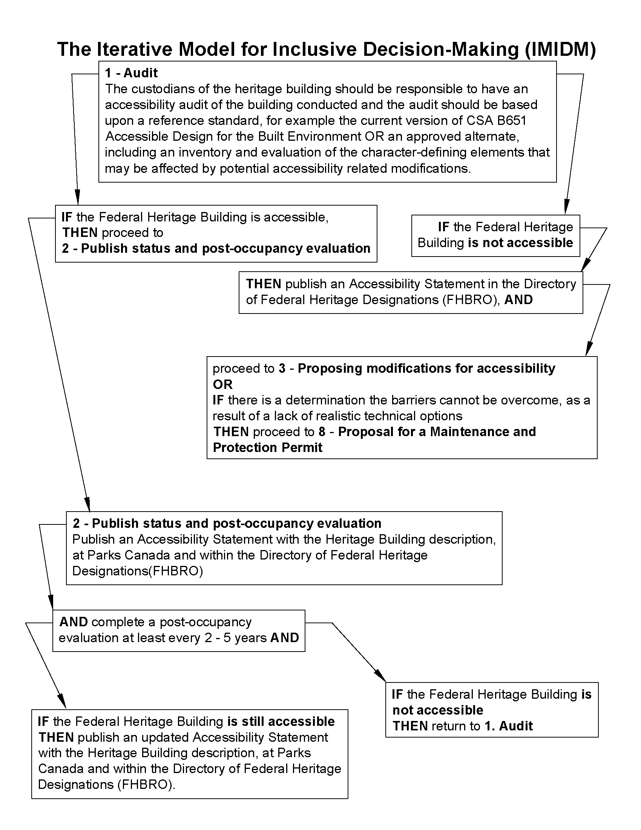

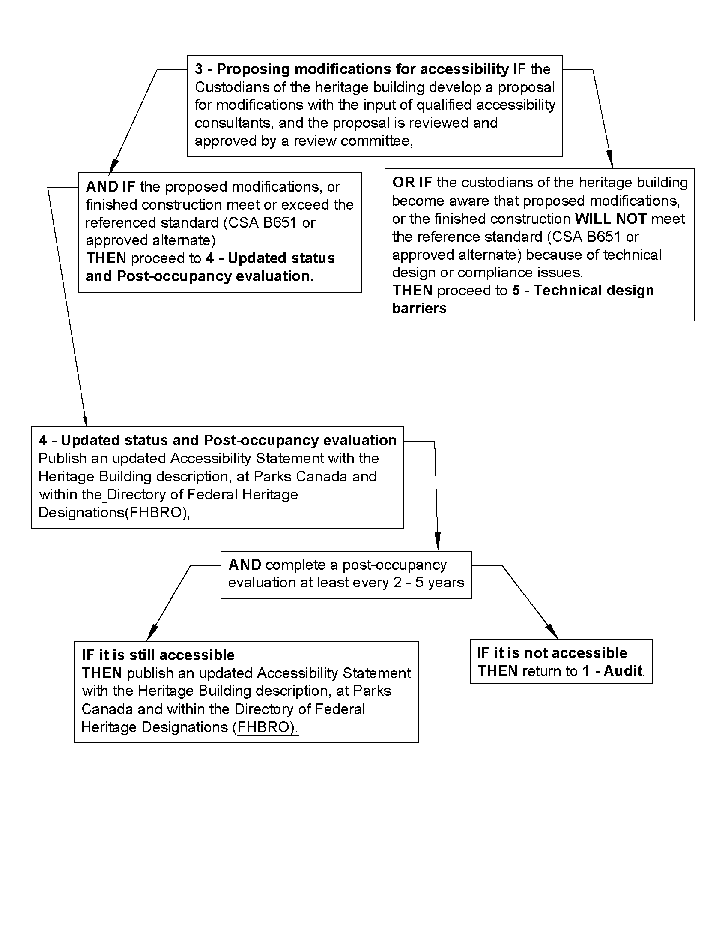

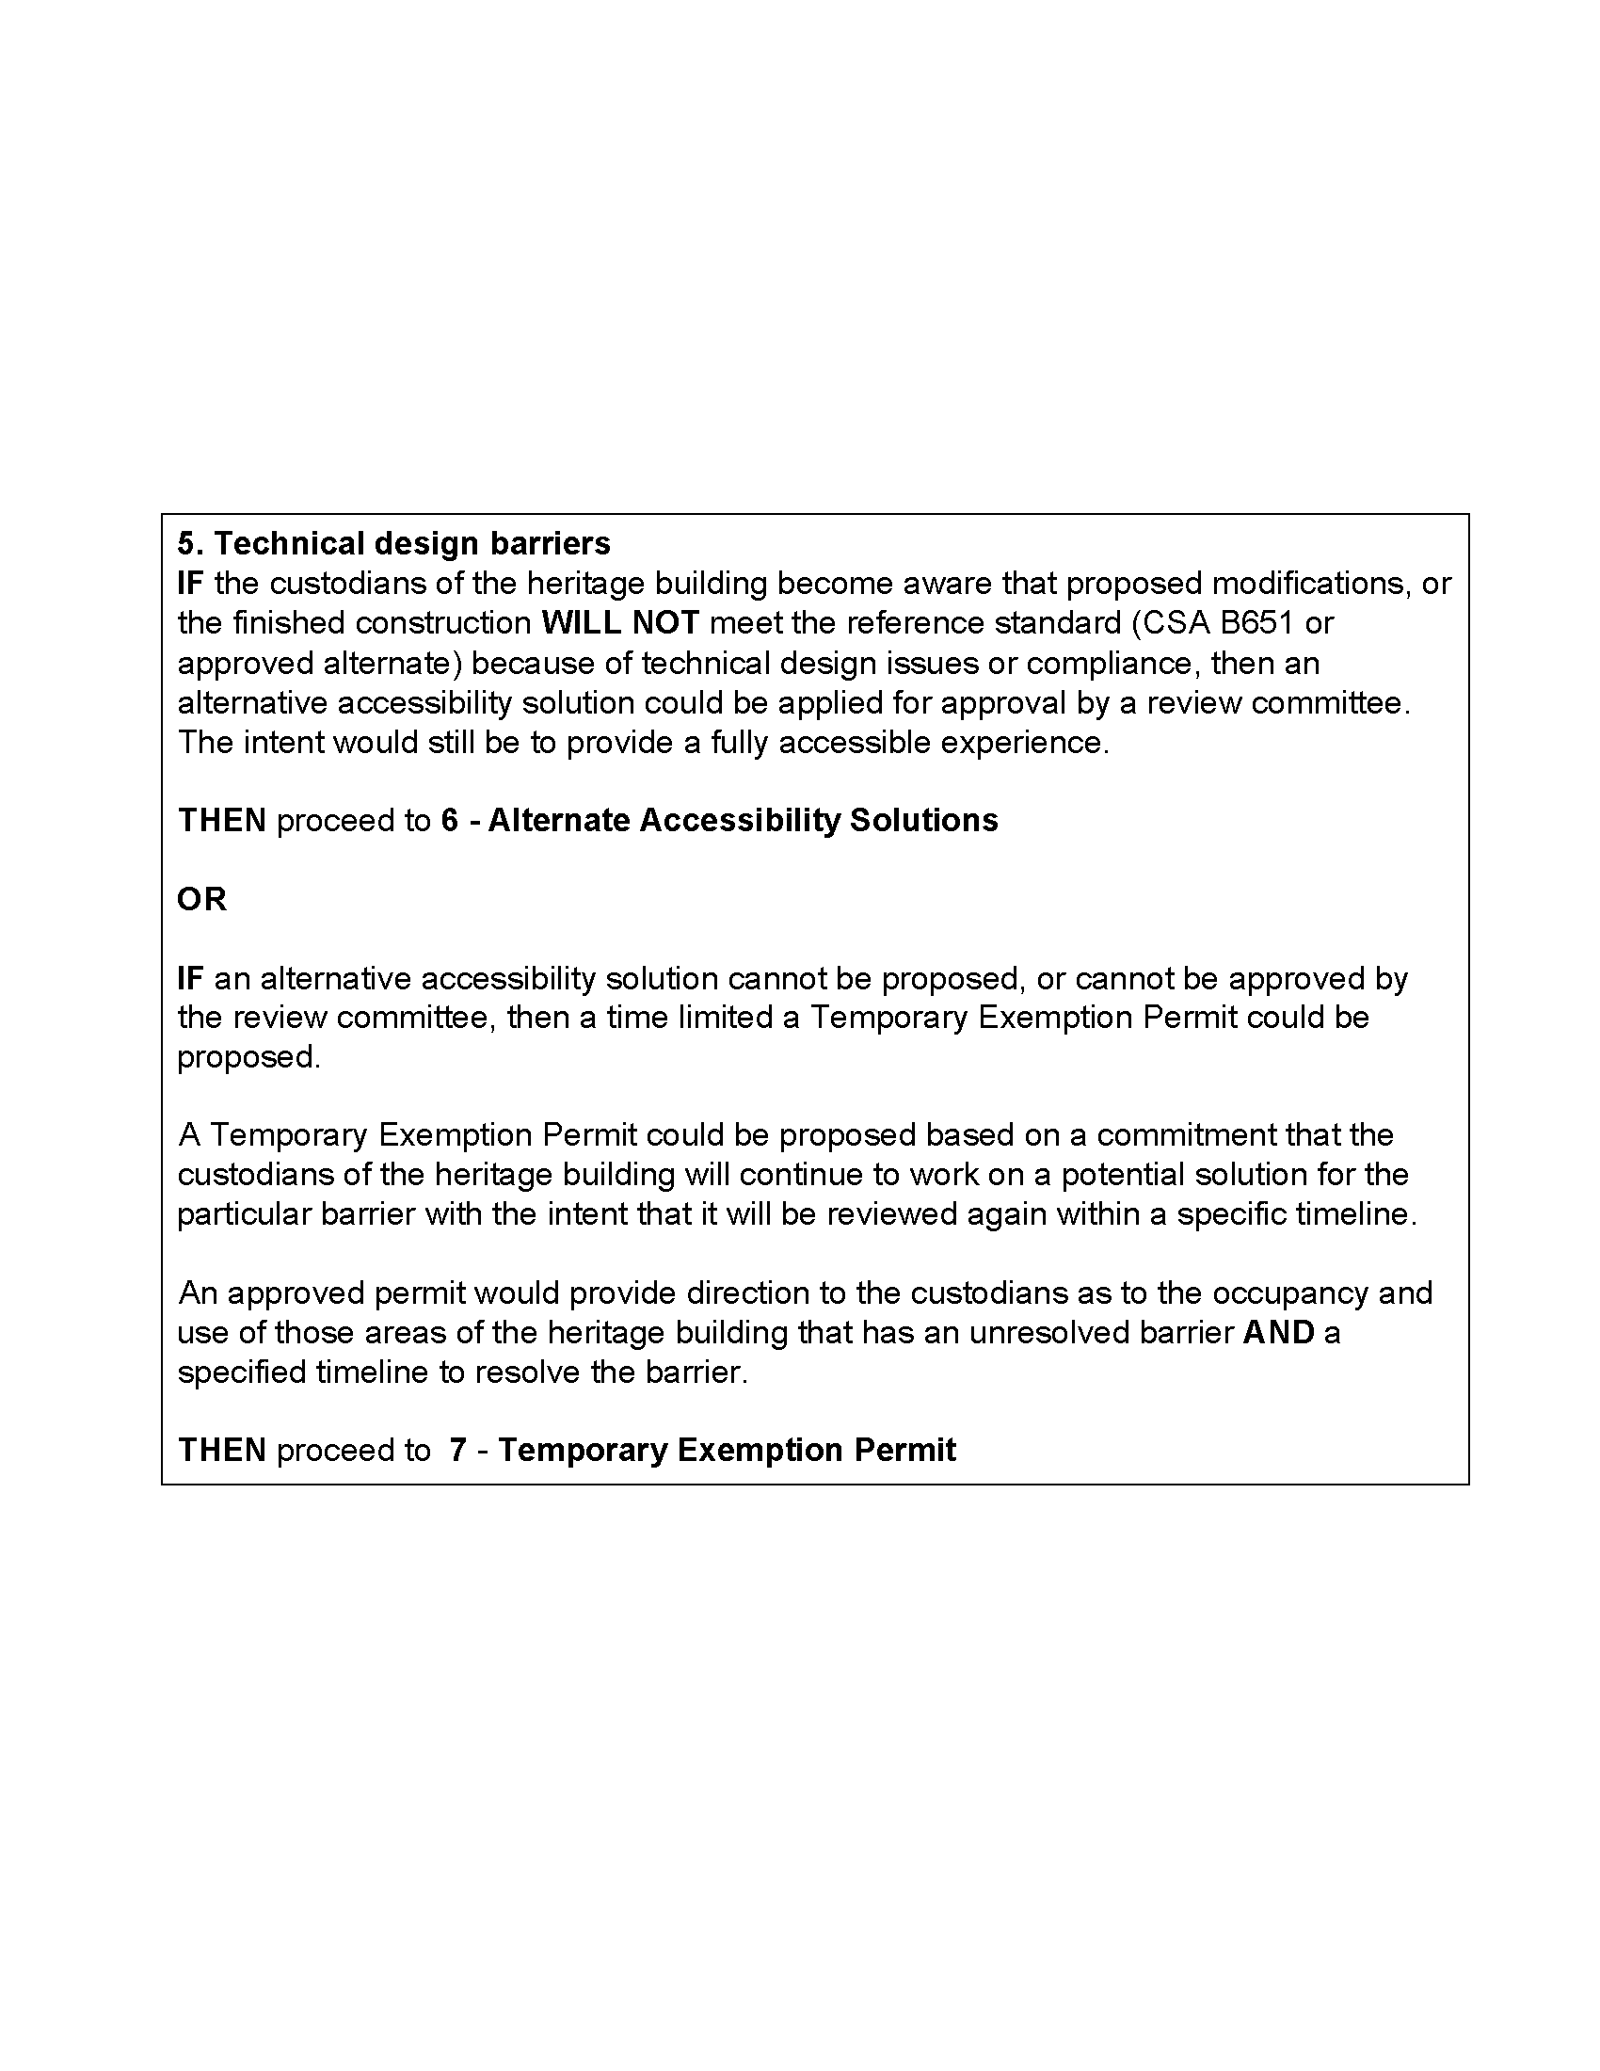

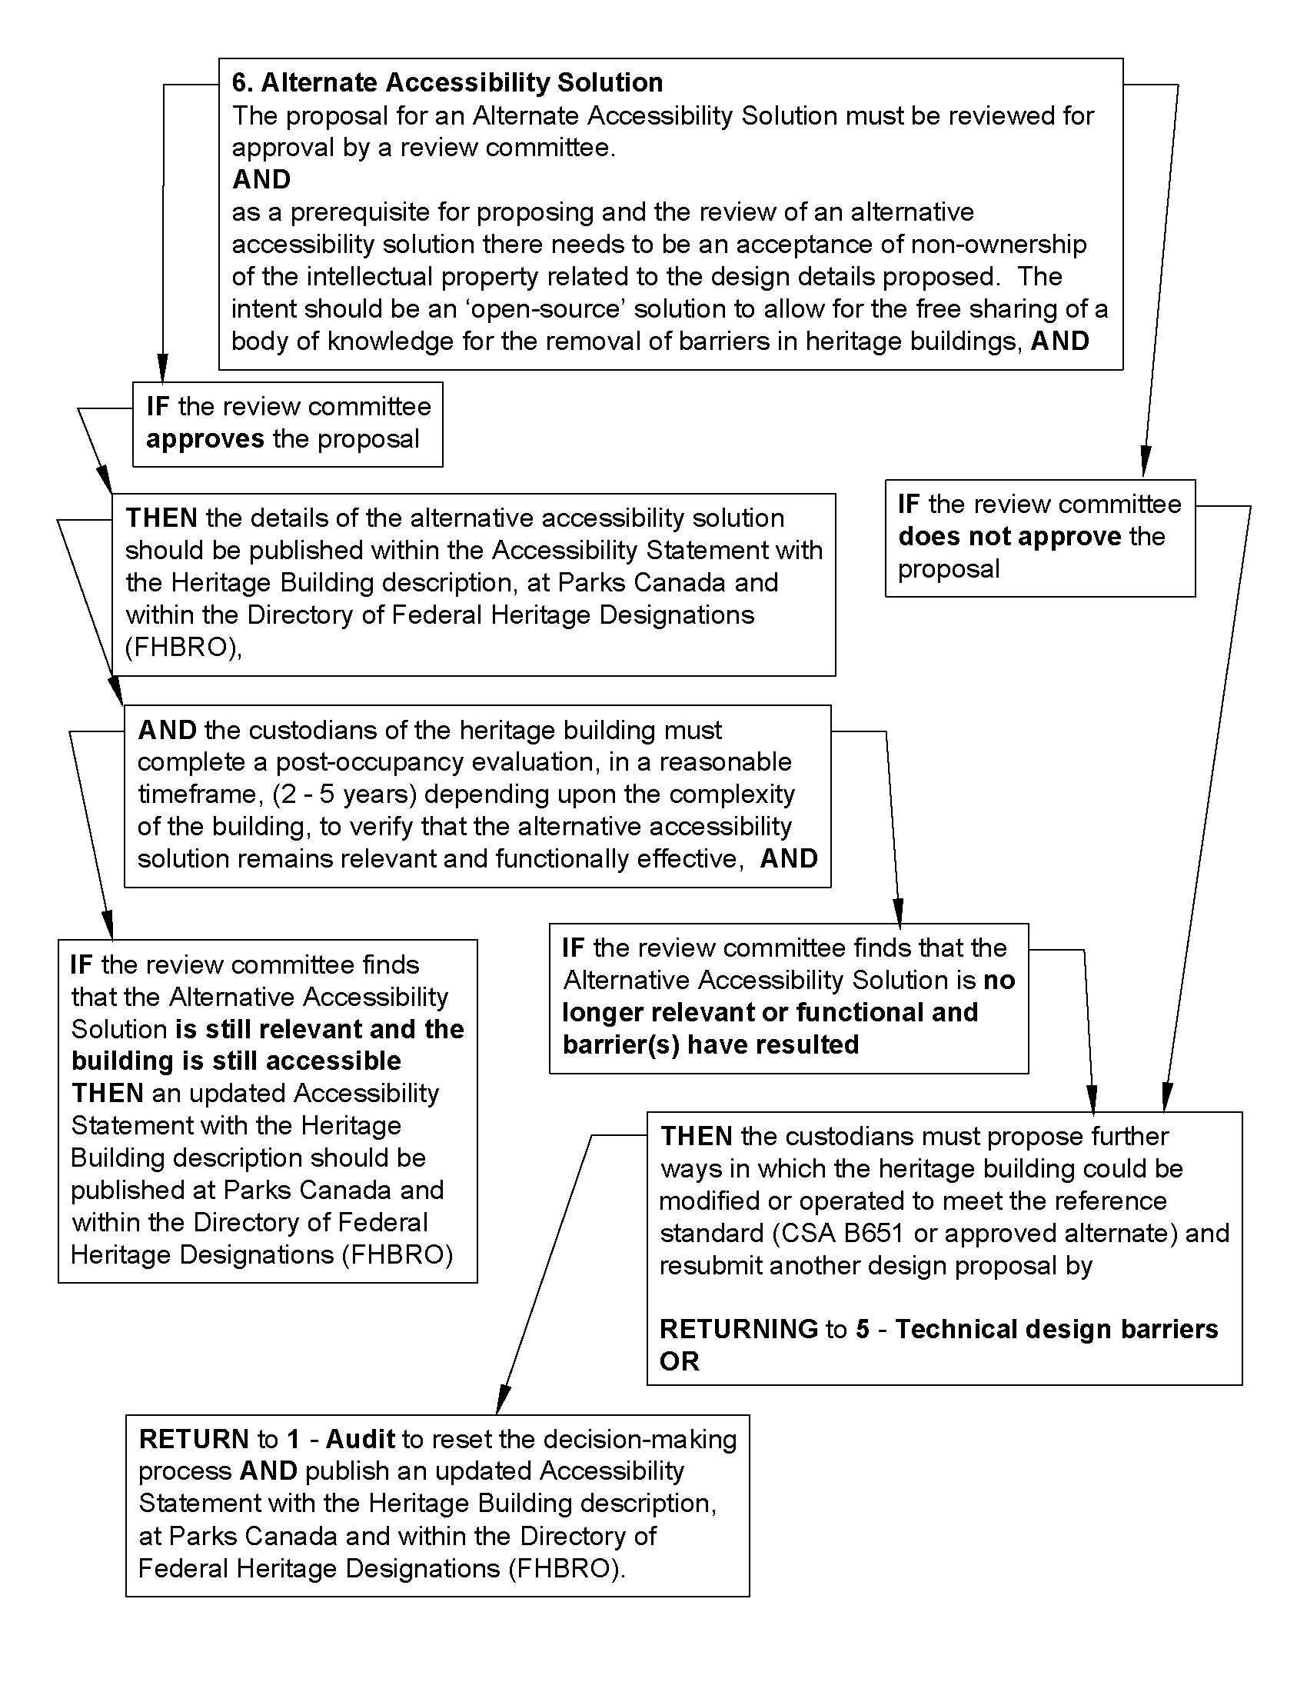

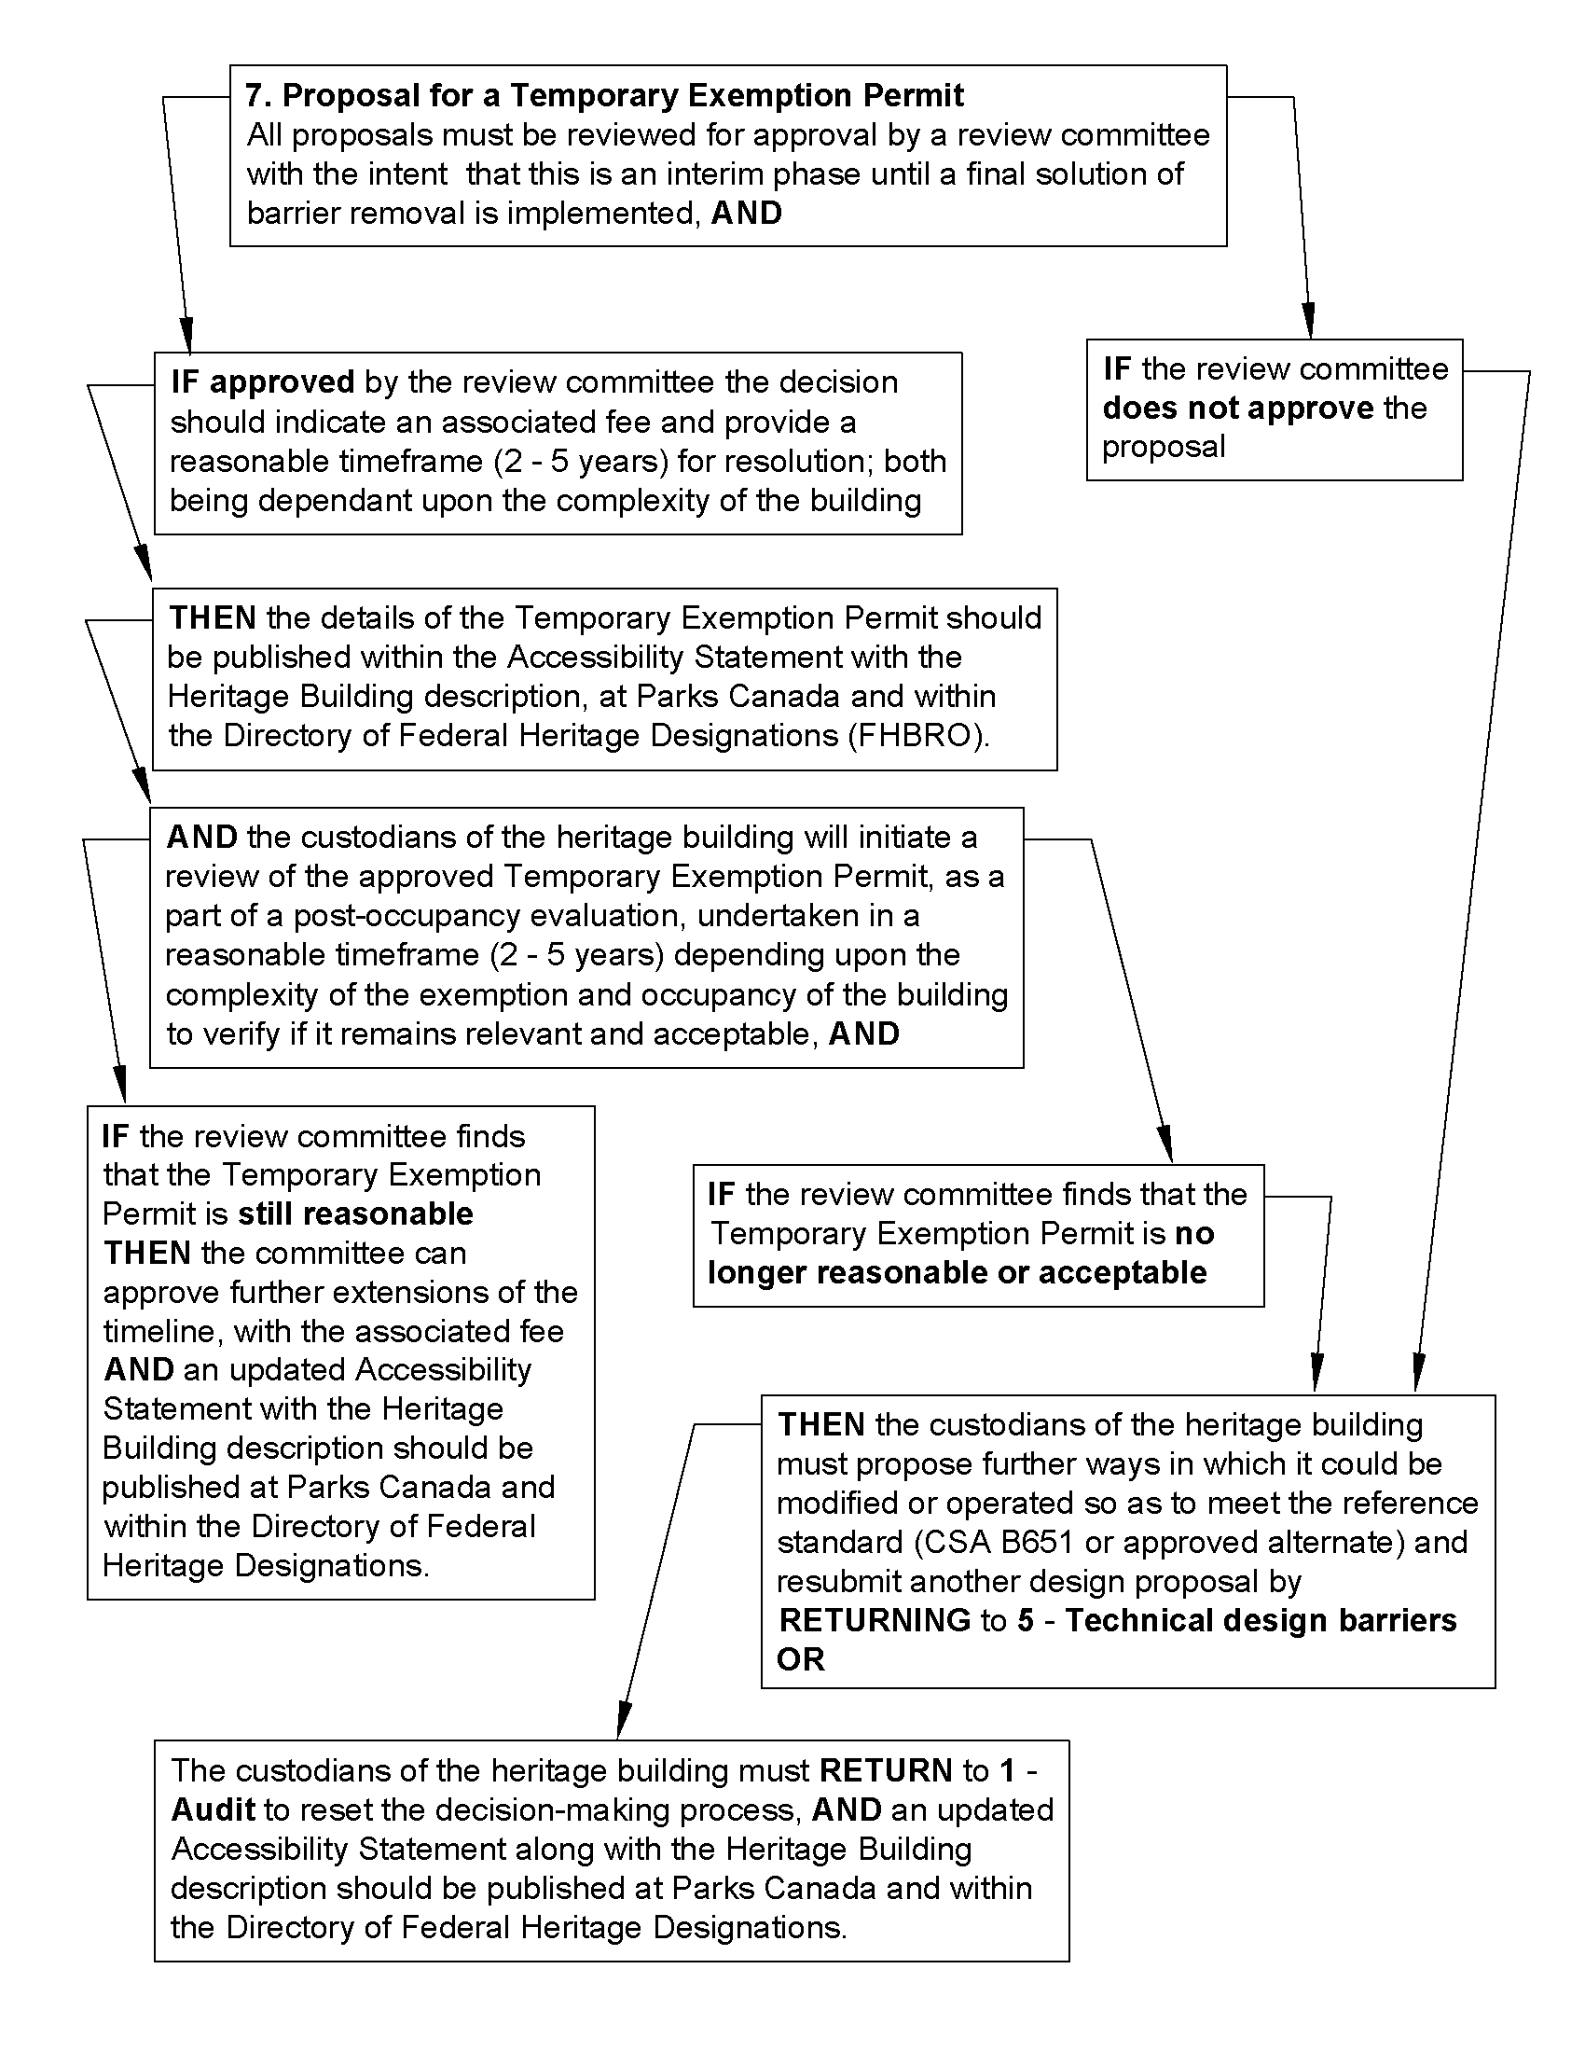

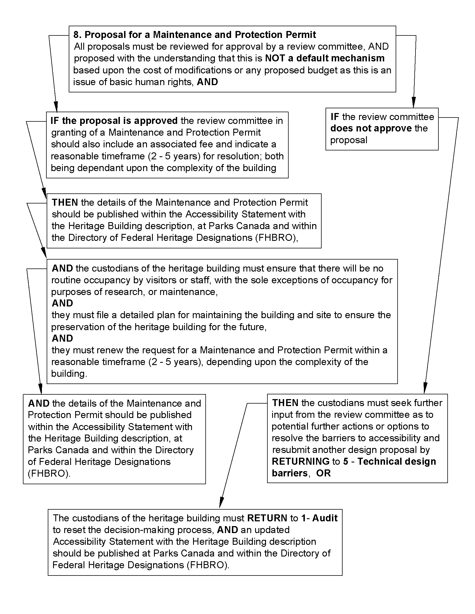

Recommendations Supporting the IMIDM Process

Reinforce Accessibility as a Fundamental Right Within Standards
The literature review highlighted the reoccurring issue, both within Canada, and internationally, of the lack of regulatory enforcement in the current approaches to heritage preservation within the context of Human Rights legislation.

Within Canada, this lack of enforcement seems to be contradictory to the intent of Canada being a signatory to the UN Convention on the Rights of Persons with Disabilities (Mason and Munn-Rivard, 2021) and the Canadian Charter of Rights and Freedoms (1982). This also seems to not meet the intent of the legal requirements within Human Rights legislation at the federal level as well as those of all of the provincial and territorial governments in Canada.
As noted in the literature review the Faro Convention clearly indicates as a foundational principle that no provision of the agreement shall be interpreted so as to limit or undermine the human rights or fundamental freedoms.
The issue of human rights versus heritage preservation was clarified several times in the group meetings and various discussions with legal experts that indicated that there is no exemption to human rights legislation for the protection or conservation of buildings in Canada.
Throughout the group meetings it was indicated that the requirement to provide accessibility to designated federal heritage buildings vital to the understanding of our Canadian culture. The seemingly non-enforcement of accessibility requirements by local building authorities having jurisdiction was thought to be no longer reasonable to suggest an exemption based on heritage conservation. This would seem to prevent an identifiable group from sharing in the Canadian heritage experience.
The group discussions clearly communicated that the wait for accessibility in Canada has been over 200 years and that is long enough. It was offered during the discussion that it is no longer acceptable to only provide “a single door to be able to enter and a toilet to pee in” (Hansen, 2023); people with disabilities have the right to be able to interact with, fundamentally come to understand the significance of, and share in the experience of Canadian heritage.
The second version of the S&G, dated 2010, does not suitably address the legal requirement for accessibility nor the fundamentals of human rights. The opening statement in the Foreword of this standard by the Chief Executive Officer of Parks Canada at the time of the publishing of this standard notes:
“On behalf of Parks Canada, I am proud to adopt the 2010 edition of the Standards and Guidelines for the Conservation of Historic Places in Canada. This document will guide Parks Canada and its partners in heritage stewardship across the country and in the establishment of world class conservation practices that help conserve our national treasures and ensure that Canadians can learn about — and have extraordinary experiences of discovery at — these historic places.” (S&G, 2010: v)
The project participants have clearly indicated that this is the problem Canadians with disabilities have as they cannot equally learn about, nor have the extraordinary experiences of discovery at these historic places.

Establish an Open Public Process and Record for Alternatives Accessibility Solutions and Temporary Exemptions
The design disciplines that deal with buildings and construction have always sought to protect their work under the laws that govern intellectual property. This is a basic tool for business that is founded on legal principles that date back to the 1400’s in Italy with architect Filippo Brunelleschi (Moore and Himma, 2022). It is clearly a principle that is foundational to practice and business.
Starting in the 1950’s the concept of public-domain software became a process produced by academics and corporate researchers. This concept of sharing of the intellectual property in the design of software does continue today by allowing the free sharing of knowledge with others to stimulate the ongoing refinement or reinterpretation of the design.
Many professionals in the information technology field have come to understand the common-good that open-source software development has had in their industry. The industry experts suggest that there is an annual savings of over $60 billion globally in the information technology field (Standish Newsroom, 2012). The potential open-source sharing of alternative accessibility solutions could benefit the field of heritage conservation within Canada and provide potential valid solutions to accessibility barriers internationally.
As it has been identified previously in this report, designated heritage buildings are typically unique models of a building type, construction, or representation of an era. As such any actions taken to modify the existing built environment or to provide an alternative accessibility solution to inform the heritage story to the visitors may need to fall outside the prescribed metrics in the codes and standards. Any reviewed and approved solution, or the need to seek more time to resolve complex barriers, could also benefit with a method to share this knowledge with others. The ability to share the details would seem to contradict the intellectual property rights of the individual professional designer.
The ability to establish free sharing of the knowledge of how to resolve unique barriers to accessibility in heritage buildings will create a resource for all professional designers and the custodians of heritage buildings. An open-source method to find concepts and innovations could be foundational to resolving barriers within heritage buildings.

An allowance for the free sharing of proven innovation could be an incubator for further refined or variant solutions that might apply for a different building type, construction, or variants of another era. The real intent here is to reduce the reinventing of a solution for individual heritage buildings. The alternative reuse of innovation could significantly reduce the timelines and development cost for the removal of barriers.
It is clear there is a lot of work to be completed to provide accessibility to the inventory of designated Federal Heritage Buildings. Any action that might reduce the time it takes to resolve accessibility should be considered. The reuse of proven concepts and innovations creates a commonality in the way to achieve accessibility at the various designated heritage sites. This will provide familiarity in details and accommodations. The common language of details and accommodations is an encouraged accessible design approach.
The proposed IMIDM process is suggesting that as part of the conditions of a request for an alternative accessibility solution for any site, it will require that the design team consent to the free open-source sharing of the details. The details of an approved and implemented alternative accessibility solution should be publicly posted. This information will allow anyone to be aware of what might be the unique nature of accommodation at the specific heritage site.
Similarly, the proposed Iterative Model of Inclusive Decision-Making in heritage buildings is suggesting that a request for an approval for a Temporary Exemption Permit for any site should be publicly posted. The public posting of the information allows for the sharing of the details and to inform anyone who might be involved with, or simply wanting to visit, the specific site, to be aware of what might be the unique nature of non-compliance at that specific site and a timeline for resolution.

As was noted previously in the discussion paper by J.Frye et al (1998) there are also numerous administrative and potential forensic reasons to maintaining a public record of these decisions as custodians, staff, and government departments change.

Cyclical Post Occupancy Reviews
As noted in the proposed Iterative Model of Inclusive Decision-Making in heritage buildings there will continue to be shifts and changes in technology. Compounding this will be changes or deterioration of the construction, or proposed new construction that may also impact the accessibility of designated Federal Heritage Buildings.

For this reason, the model addresses the need to create a cyclical approach to reviewing the inventory of designated Federal Heritage Buildings. This is an important issue from the perspective of the custodians and departments managing the heritage buildings. Consideration should be given to routine audits to ensure the site complies with the intent of the Accessible Canada Act.
Equally, the cyclical updating of the accessibility information about the individual designated Federal Heritage Buildings is important to people who might attend the site. People require current information that describes the accommodations or any Temporary Exemption Permits that might affect their ability to access and experience the site.
As additional buildings are proposed to be included in the listing of designated heritage buildings, and at the point of proposing modifications to any of the designated Federal Heritage Buildings, there would be a benefit to have a database of information to draw upon that could highlight the most current information regarding the ways in which other projects have implemented change. The sharing information and listening to other voices is a fundamental building block to the proposed approach.

Evolution of Heritage Stories Versus a Collection of Artifacts
The literature review provided substantial evidence to the shift from conservation of heritage artifacts to the process of preservation and sharing of cultural heritage. This shift was further substantiated throughout the project by the various experts and individuals who work in the heritage field. This change is not dismissing the need to conserve heritage artifacts, but rather is promoting the importance of the history, the story, that the artifacts resonate. This does provide an opportunity for design teams and custodians to be creative and be more inclusive in how to share the history, the story.
There are building forms within the inventory of designated Federal Heritage Buildings that are inherently complex with respect to accessibility, if the intent is solely to occupy the building and provide equal access to information describing the conserved artifacts. Examples of these building types would include most lighthouses, unique industrial and mining sites, and some iconic sites such as the Cabot Tower in St. John’s, Newfoundland.
In situations where a building type or form would require such significant alteration or addition to accommodate a basic accessible path of travel there is a strong argument made from a heritage perspective that if an alteration or addition could be pursued it may significantly detract from the original form of the building. The changes would alter the form and massing of the building, (i.e. a lighthouse) which are the significant character-defining elements.
As stated previously, every heritage building is unique and may require customized interventions. As a part of an accessibility audit the project team should have the ability to critically examine which character-defining elements could be sacrificed to make accessibility improvements. For instance, does the entire Supreme Court staircase need to remain? Can a portion of it be demolished to install an enclosed lift? These new interventions will then demonstrate that the story of the building evolves over time, adding new layers for inclusivity. And without these new layers, the building would become rendered unusable / irrelevant / a dinosaur.
For those buildings that cannot be modified by alteration or an addition without affecting the heritage designation, then this is a loss of history for Canadians until an alternative accessibility solution can be developed and implemented.
The shift to telling the heritage story, or cultural heritage, is as an alternate approach that provides an opportunity to be done in an inclusive way. This could be in the form of an interpretive centre, technological interactive displays, interpretive models, or other creative means. This was noted previously when using the example of the Riel House in Winnipeg. Cultural heritage story telling offers far more opportunity to be made accessible and provides far more insight into the story of Canada.

Inclusivity Before the Front Door - Travel Route and Site Conditions
This research project has been defined to be informing accessibility standards development for Federal Heritage Buildings. From a code and standards development methodology the project team has understood the need to limit the discussion to buildings and not include aspects of site accessibility. Site development standards are typically separate and unique as compared to building and construction criteria.
The project team did however indicate throughout the project that it is very difficult to divorce site accessibility from building accessibility. If the site is inherently inaccessible, often because of geographic or inhospitable terrain conditions, why develop an accessible plan for the building?

An example might be the York Factory National Historic Site that requires transportation by boat to a dock that includes a lengthy set of stairs to reach the level of the land where the buildings are located. Another example would be Grey Owl’s Cabin in Saskatchewan where there is a very convoluted route including water routes with rapids and rough hiking trails, but the heritage story is that of seclusion.
“Far enough away to gain seclusion, yet within reach of those whose genuine interest prompts them to make the trip, Beaver Lodge extends a welcome to you if your heart is right.” (Grey Owl, https://parks.canada.ca/pn-np/sk/princealbert/activ/experiences/randonee-hiking/cabane-cabin, last accessed August 2023).
In the previous section it was noted that the Cabot Tower in St. John’s Newfoundland is a building that would be complex to modify for accessibility yet retaining the heritage status. The building is located on Signal Hill which is also a National Historic Site. The elevation is more than 500 feet above sea level of the harbour below.

The site does include an interpretive centre at a lower elevation that includes accessible vehicle parking. But because of having a public roadway that can take anyone to the base of Cabot Tower, anyone, regardless of ability, could use accessible transportation to arrive at the lookout area some 500 feet above the harbour. In this situation the site has been made accessible, but the building (Cabot Tower) remains inaccessible for visitors with disabilities.
Heritage buildings and the site where they are located both interact with people’s ability to share in the Canadian cultural history story to be told.

Further Support for Change in the Future
It is noted in the proposed IMIDM that there should be a fee attached to a Temporary Exemption Permit and a Maintenance and Protection Permit. The working group expressed the desire to also create an opportunity to support the on-going commitment to accessible Federal Heritage Buildings by suggesting that this model could have ‘fees’ associated and payable into a ‘federal heritage building fund’ that could support further accessibility improvements at various sites in the future.

Additional Recommendations
- With the suggested requirements for the involvement of people with disabilities in review processes for designated Federal Heritage Buildings it would provide additional employment opportunities for this sector. This would also develop a pool of experts to draw upon for not just heritage, but all forms of accessibility inputs for built-environment projects across Canada.
- The suggested process would create opportunities for cross pollination of information and experience between the design, construction, facility management, and disability sectors. The resulting body of knowledge and expertise would be invaluable to all levels of governments in Canada, as well as the private sector.
- The suggested process would create greater public information and ultimately awareness regarding the accessibility at Federal Heritage Buildings and in a much broader view, the sharing of the cultural heritage of Canada. This could become a vital source of information for newcomers to Canada.
- Utilize the IMIDM alternative accessibility solution database to inform the writing or updating of application statements, prescriptive requirements, or advisory appendices with respect to heritage buildings in existing codes and standards.
- There is a gap in the current educational systems in relation to the design and construction of accessible environments. There is an opportunity for the senior level of government to provide support and guidance to develop a national model, and/or make recommendations to the provinces and territories, for a post-secondary level program to qualify accessibility consultants.

- There is typically a significant lag in the Treasury Board of Canada adoption of the most current edition of CSA B651 Accessible Design for the Built Environment. The Canadian Standards Association continues to work on upgrading this standard based upon changes in the field and expectations of Canadian society.
Consideration should be given to mandating earlier and timely reviews of any updated versions of the CSA B651 standard. Adoption of the most current standards will achieve greater accessibility for Canadians.
- The Government of Canada, through Parks Canada, should consider a major review and update of the 2010 version of the Standards and Guidelines for the Conservation of Historic Places in Canada.
The revisions to this standard should reflect not only enhanced accessibility requirements, but also to reflect Canada's commitment to the UN's Convention on the Rights of Persons with Disabilities AND to include referencing to the most current version of the CSA B651 design standard.
- The Government of Canada, through Parks Canada, should consider a major review and update of the 2010 versions S&G to update the process and criteria to a more objective rationale used to establish the statements for heritage value and character-defining elements. It was identified in the working group discussions of several sample listings of designated heritage buildings the seemingly subjectivity of some the descriptions for these key elements that are often significant barriers to accessibility.

- Consideration should be given by Accessibility Standards Canada, in conjunction with the Canadian Standards Association, and Parks Canada to collaborate on a process, specific to heritage buildings that would integrate the commemoration or heritage story as an experience for all who attend the building.
The experience of this should be an equally valued element, similar to the other protected aspects of a site like the character-defining elements. This could provide alternative opportunities to inclusion at heritage sites; accommodation by way of a more robust method of experiencing the history and lessons learned thereby proving greater set of tools and values to portray at heritage sites.

- Consideration should be given by Employment and Social Development Canada, in collaboration with those responsible for the online Government of Canada information regarding all Federal Heritage Buildings be available in accessible formats, and that all information regarding accessibility at federal government buildings and sites be uniform in content and context throughout the departments and agencies.
- Consideration should be given by Employment and Social Development Canada and Accessibility Standards Canada to support broader professional education within the design and heritage disciplines to include disability awareness, the legal responsibility for accessibility, and the specific functional requirements necessary for the creation of inclusivity.
- Consideration should be given by Employment and Social Development Canada and ASC to develop a comprehensive public education campaign that provides a broader perspective of accessibility and inclusivity to be promoted to the general public.
- Consideration should be given to requiring Parks Canada to provide a detailed public report, annually, on the progress made relative to accessibility to designated Federal Heritage Buildings.
- Consideration should be given by Employment and Social Development Canada and ASC, in conjunction with Parks Canada, to develop a compliance unit for federal heritage projects. This compliance unit would conduct reviews of modification projects to Federal Heritage Buildings and provide continued post-occupancy evaluation as recommended in the IMIDM.
- Consideration should be given by ASC, in conjunction with Parks Canada, for the creation of a public forum for alternative accessibility solutions approved and completed at Federal Heritage Buildings. This information, when shared publicly becomes a source of information and ideas for other non-federal heritage sites and adds to the public dialogue on rising to the challenge to an inclusive Canada.
- Consideration should be given by the National Research Council with respect to the National Building Code of Canada, as well as Canadian Standards Association and ASC to provide guidance in appendices or notations to recognize that barriers to the built environment are not solely physical or sensory, but in fact may also be emotional, behavioural, psychological, or cultural barriers.
There may be an intersectionality of these barriers with physical or sensory barriers that can negatively affect full inclusion in society. The compounding of these various barriers can significantly obstruct participation or experience within a heritage environment.
For example, the appearance of a building that could resemble a residential school building, or an institutional care building, can become a significant barrier for some people. Documentation of the historic uses or occupancies of building should be provided as a part of the full disclosure of the site experience. This allows visitors, volunteers, or staff to come to understand and make informed decisions prior to arrival at the site.
- The Government of Canada, through Parks Canada, should consider a major review and update of the 2010 version of the S&G to provide background, based upon historic evidence, that specific barriers to full inclusion were never considered at the time of the original construction. This is a part of the history of systemic exclusion of groups identified in the Canadian Charter of Rights and Freedoms.
Examples of typical barriers that might be encountered could include the lack of high contrasting paint colours to provide safer circulation with limited vision, the lack of level entries or ramps, or the lack of washrooms or limited size washrooms.
Although this acceptance of exclusion may be evident in the physicality of the buildings, but it may also be inherent in the story being portrayed as the experience of cultural heritage.
The story being experienced, documented, or narrated also should expose why and how identifiable segments of Canadian society may not have been allowed to use, enter, or be considered in the time-period being portrayed. The presentation of a given historic place may speak to prejudices of the past and the lessons learned moving forward.

Appendix A: Analysis National Energy Code and National Fire Code

Analysis of requirements in the National Energy Code of Canada and the National Fire Code of Canada for additional conflicts with accessibility standards.

National Energy Code of Canada for Buildings

As a part of the literature review the 2020 edition of the National Energy Code of Canada for Buildings (NEC) was reviewed to try to identify any potential conflicts that might occur if more stringent application of accessibility functionality was applied to federal heritage buildings.
The basic intent of the NEC is a response to climate change and to focus on sustainable practices for the building industry sector. In the front-end documentation of this code it does indicate that it does apply to existing buildings and to the construction of any addition to an existing building. The trigger for an addition is any construction that increases the building surface floor area by more than 10 m2 (107.6 sq.ft.).

On that basis it would seem to be possible to do some minor modifications to the configuration of entry spaces (a common accessibility barrier) without triggering the more onerous requirements of the NEC to the entire existing building. Further to this point is found in Division A Part 1 Compliance, the Appendix note A-1.1.1.1.(1) offers the clarification:

“For the purpose of understanding the scope of this Code, an addition can be thought of as a new building that happens to be built contiguous to an existing building or as a new portion of an existing building.” (2020: 1-11)

This is further reinforced in Section 8 of NEC, Subsection 8.4.1.4. with regards to the application of the Performance Path to an addition to an existing building. On that basis the NEC offers options to the design of additions that might be necessary for an existing building, including heritage buildings, to allow for additions necessary to accommodate the required accessibility, without necessarily triggering the full requirements of the NEC to the existing construction of the heritage building.

Beyond physical space for circulation the second most common factor related to accessibility functionality that the scope of the NEC could potentially trigger requirements is in relation to modifications to the plumbing infrastructure. The extent of this would likely be limited to energy requirements related to “service water”. This could trigger some requirements dealing with insulation of water supply, and flow rates of fixtures. These requirements would not seem to be onerous when applied to smaller heritage buildings that may need to be modified to provide accessible washrooms.

However, in the context of a larger heritage building that is being redeveloped as an ‘alternate-use’ project the application of the NEC could be onerous, but this would be in the context of the overall project requirements. The modifications required for the necessary accessibility functionality would still likely be in relation to the overall requirements and budget factors.

The other major factor in the NEC that could impact the accessibility functionality in a heritage building is with regards to lighting and lighting controls. The design of the lighting system in a heritage building must provide sufficient light level for people with limited vision, or difficulties with perception, to be able to safely move within the built environment, and to be able to participate and experience these spaces. The NEC would not seem to prevent this from happening as the requirements with the NEC are solely based on an energy conservation perspective. Careful design of the lighting would be critical to ensure that the functionality was provided for the experience of the broader range of occupants in the building, while meeting the requirements for lower energy consumption.
If the lighting design is not functionally appropriate, then the occupants may be faced with barriers which create stress and require more personal energy in order to participate and experience the built environment.

The Division C of the NEC does also provide an opportunity for the application of an “alternative solution” under section 2.3. This could be used in the situation of accommodating the accessibility requirements in a specific heritage building when the acceptable or prescriptive solution could be problematic from either the perspective of the conservation or the accessibility requirements.
The preservation practices of heritage professionals based upon the benchmarked guidelines in the Standards and Guidelines For the Conservation of Historic Places in Canada (2010) further support the intent of sustainability. The current shift in heritage thinking away from the traditional concepts of ‘frozen-in- time’ preservation to a broader comprehensive approach to preservation of cultural heritage that can promote reuse and greater access to the heritage buildings by the broader community. This can provide an opportunity for further synergies between the requirements of sustainability and the requirements for equal use and enjoyment by all Canadians, including people with disabilities.

National Fire Code of Canada

As a part of the literature review the 2020 edition of the National Fire Code of Canada (NFC) was reviewed to try to identify any potential conflicts that might occur if more stringent application of accessibility functionality was applied to federal heritage buildings.

By definition, the majority of the technical provisions in the NFC are related to existing buildings. The NFC does regulate some “activities related to the construction, use or demolition of buildings and facilities”. However, the major focus of the NFC does apply to the vast majority of existing buildings in Canada. The main objectives of the NFC are safety, health, and the fire protection of buildings and facilities.

As an objective-based code, the NFC “OS Safety” objective, subsection -
OS3 Safety in Use includes:
“An objective of this Code is to limit the probability that, as a result of
    - activities related to the construction, use or demolition of the building or facility,
    - the condition of specific elements of the building or facility,
    - the design or construction of specific elements of the facility related to certain hazards, or
    - inadequate built-in protection measures for the current or intended use of the building,
a person in or adjacent to the building or facility will be exposed to an unacceptable risk of injury due to hazards. The risks of injury due to hazards addressed in this Code are those caused by -

OS3.1 – tripping, slipping, falling, contact, drowning or collision
OS3.2 – contact with hot surfaces or substances
OS3.3 – contact with energized equipment
OS3.4 – exposure to hazardous substances
OS3.7 – persons being delayed in or impeded from moving to a safe place during an emergency (see Note A-2.2.1.1.(1))” (quoted from NFC 2020: 2-2)

The Appendix note A-2.2.1.1.(1) further reinforces that this threat is not solely in situations of fire:

“Emergency: The term ‘emergency’—in the context of safety in buildings or facilities—is often equated to the term “fire emergency;” however, the wording of objective OS3.7 makes it clear that the Code addresses any type of emergency that would require the rapid evacuation of the building or facility, such as a bomb threat or the presence of intruders.”

This appendix note further expands on Fire Safety in relation to person:
“refers to any individual in or adjacent to the building or facility, including the occupants, the public, and emergency responders including firefighters when performing their duties.” (quoted from NFC 2020: 2-5)

On that basis the NFC does not seem to distinguish that there are ‘special’ or different requirements for people with disabilities and that all existing buildings must operate under the terms of the stated objectives in OS3.

Therefore, the language of OS3 could be summarized to indicate that all buildings / facilities in use should be operated and maintained in a manner to mitigate any occupant (‘person’) from being exposed to an unacceptable risk of injury caused by tripping, slipping, falling, contact, drowning, or collision, and being delayed in or impeded from moving to a safe place in an emergency.

This language seems to strongly support the intent of a major portion of what is an accessible built environment. However, the NFC does clarify in the appendix noted to Division C Section 2.2 Administration:

“The nature and extent of the enforcement powers to be employed by governments are not technical issues, but are rather policy issues for the appropriate government to decide.” (quoted from NFC 2020: 2-1)

On that basis, the NFC is a model code, and it is within the purview of the provincial and territorial governments to adopt and apply the technical requirements.

Considering the approximate 1300 federal heritage buildings, it does leave one to question the application of the OS3 objective that would reinforce changes to the built environment of heritage buildings so as to better address the requirements for accessibility in light of the requirement to mitigate the risk for all occupants from being exposed to an unacceptable risk of injury caused by tripping, slipping, falling, contact, drowning, or collision, and being delayed in or impeded from moving to a safe place in an emergency.

This also raises the question of code enforcement, especially in light of this NFC objective, as it does seem to be in conflict with the stated recommendation of the from the Standards and Guidelines For the Conservation of Historic Places in Canada (2010):

“best balance of accessibility needs with heritage value are those that enhance the use and appreciation of an historic place for everyone” (2010: 42)

Should the objective of safety for all occupants in the NFC be balanced with, or lessened as a result of, the heritage values of the defined character-defining elements registered in the Directory of Federal Heritage Designations at the Federal Heritage Building Review Office?

Bibliography
ACCESSIBILITY STANDARDS CANADA. meeting held September 20, 2022.
ANGEL, V., Editor, (undated), A Guide to Working with The Federal Heritage Building Review Office.; prepared by the Federal Heritage Buildings Review Office (FHBRO). publications.gc.ca , [last accessed August 2023], p. 3.
ANTANAITYTÉ, G., URBOAITE-VADOKLIENÉ, I., (2017). Adapting Participatory Design Tools in Design Through Research (DTR) Models to Develop Sustainable Projects in Sensitive Territories. Case Analysis, Journal of Sustainable Architecture and Civil Engineering. v. 3, n. 20/2017, p. 12.
ASSOCIATION OF CONSULTANTS IN ACCESS AUSTRALIA INC., (2023). Access Peer Reviews of Performance Solutions. https://accesspeerreviews.com.au . p. 12 and www.access.asn.au . [accessed last August 2023].
BARRETT, P., ORMEROD, M., & NEWTON, R., (1999). A feasibility study into creating accessible environments within the briefing process. University of Salford, The Centre for Accessible Environments. Engineering and Physical Sciences Research Council. (unpublished).
BLOCK, P., (2008). Designing Physical Space that Supports Community. Community: The structure of belonging, California. U.S.A. Barrett-Koehler Publishers Inc. c. 14, p. 162.
CANADA’S HISTORIC PLACES, (2010). Standards and Guidelines for the Conservation of Historic Places in Canada. Parks Canada, Second Edition, p. 42.
CANADIAN COMMISSION ON BUILDING AND FIRE CODES: NATIONAL RESEARCH COUNCIL OF CANADA, (2020). Energy, National Energy Code of Canada for Buildings 2020. Fifth Edition.

CANADIAN COMMISSION ON BUILDING AND FIRE CODES: NATIONAL RESEARCH COUNCIL OF CANADA, (2020). National Building Code of Canada 2020. Volumes 1 and 2, Fifteenth Edition.

CANADIAN COMMISSION ON BUILDING AND FIRE CODES: NATIONAL RESEARCH COUNCIL OF CANADA, (2020). The National Fire Code of Canada 2020. Eleventh Edition.

CENTRE FOR INCLUSIVE DESIGN AND ENVIRONMENTAL ACCESS, (2023) University of Buffalo, Available from http://www.ap.buffalo.edu/idea/Home/index.asp , [accessed August 2023]

CHECKLAND, P., (2000). Soft Systems Methodology: A thirty year retrospective, in Systems Research and Behavioural Science. Interscience. U.K.: Whiley, November 2000, S11-S39.
CHISCANO, M., AND BINKHORST, E., (2019). Heritage sites experience design with special needs customers. International Journal of Contemporary Hospitality Management. Emerald Publishing Ltd., v. 31, n.11, p. 4212.
CHURCHILL, W., 1948. Speech to the House of Commons, https://quote.org/quote/those-who-fail-to-learn-from-history-645821 or https://www.quora.com/When-did-Churchill-say-those-who-fail-to-learn-from-history-are-doomed-to-repeat-it
COLEMAN, R., LEBBON, C., CLARKSON, P.. AND KEATES, S., (2006). Introduction: From Margins to Mainstream. Inclusive Design. p.8.

CORRY, SHAUNA, (2001). Post-Occupancy Evaluations from a Universal Design Perspective, Universal Design Handbook, Preiser, W., and Ostroff, E. Eds U.S.A. McGraw-Hill Companies Inc. p. 56.1 – 56.12.

COUNCIL OF CANADIANS WITH DISABILITIES, (February 2011). UN Convention on the Rights of Persons with Disabilities: Making Domestic Implementation Real and Meaningful. CCD – CACL Working Paper. http://www.ccdonline.ca/en/international/un/canada/making-domestic-implementation-real-and-meaningful-feb2011#:~:text=Canada%20ratified%20the%20CRPD%20on,governments%20and%20persons%20with%20disabilities.

COUNCIL OF EUROPE Treaty Series Explanatory Report , (2005). To the Council of Europe Framework: Convention on the Value of Cultural Heritage for Society, Faro, No. 199, article 4, 5, & 27
CSA GROUP, (2023). B651-23: Accessible Design for the Built Environment, Canada. Canadian Standards Association. Toronto, ON.
*CULTURAL HUMAN RESOURCES COUNCIL, (undated). Human Resources in Canada’s Build Heritage Sector, Government of Canada’s Sector Council Program and Parks Canada. P. 42-43, 47, and 86.
FEDERAL HERITAGE BUILDINGS REVIEW OFFICE, parks.canada.ca [last accessed August 2023].
FINKEL, G., (1999). Wayfinding Performance by People with Visual Impairments, In Steinfeld E. and Danford,G.S eds. Enabling Environments: Measuring the impact of environment on disability and rehabilitation. New York: Kluwer Academic / Plenum Publishers, 332.
FORBES, G., (undated). Developing Traffic Engineering Guidelines and Standards, unpublished. [restated from Redmond, J., 2010, Dissertation, Reciprocal Conciliation Model: An Interactive Model of Standards Development for Accessible Environments]. p. 5.
FRYE, J., HOLLAND, F., LAWRIE, R., MCCULLOUGH, R., MURDOCH, G., AND OLESZKIEWICZ, I., (1998). Recommended Documentation Requirements for Projects Using Alternative Solutions in the Context of Objective-Based Codes. Discussion Paper, Executive Summary. p. 2.
GOVERNMENT OF CANADA, Parks Canada Directory of Federal Heritage Designations. Supreme Court Building, Character-defining Elements. https://www.pc.gc.ca/apps/dfhd/page_fhbro_eng.aspx?id=2986 , [last accessed August, 2023].
GOVERNMENT OF CANADA, (1982). The Charter of Rights and Freedoms, A guide for Canadians, Minister of Supply and Services Canada, 15 (1), 15 (2). Available from https://www.justice.gc.ca/eng/csj-sjc/rfc-dlc/ccrf-ccdl/ [last accessed August 2023].

GOVERNMENT OF CANADA, (2019). Accessible Canada Act. (amended April 2023). S.C. 2019, c.10, Section 5, 11 and 18.
HANSEN, N., (2023). Meeting dated January 17, 2023.
HAMILTON, M., (2008). Integral City, Evolutionary Intelligences for the Human Hive. B.C. Canada. New Society Publishers. p. 83-91, 173, 221, & 238.
HEYLIGHEN, A., AND VERMEERSCH, P., (2012). Inclusive Built Heritage as a Matter of Concern: A Field Experiment. In: Langdon P., Clarkson, P., Robinson, P., Lazar, J., Heylighen, A. (Eds.), Designing Inclusive Systems. London:, Springer-Verlag, c. 21, p. 207-216
IMRIE, R. & HALL, P., (2001). Inclusive Design, Designing and developing accessible environments. Inclusive Design and development in the built environment. London, UK, Spon Press, c. 1, p. 18 and c. 2,p. 31.
INCLUSION WEEK, (2008). The social model of disability, Originally available from http://inclusion.uwe.ac.uk/inclusionweek/articles/socmod.htm [Originally accessed 11 November 2008] from Redmond, J., 2010, Dissertation, Reciprocal Conciliation Model: An Interactive Model of Standards Development for Accessible Environments, (Unpublished).

INTERNATIONAL COUNCIL ON MONUMENTS AND SITES (ICOMOS), (1987). Charter For The Conservation Of Historic Towns And Urban Areas (Washington Charter 1987). icomos.org, [last accessed August 2023], p. 2.
KEATES, S. and CLARKSON, J., (2004). Countering Design Exclusion, An Introduction to inclusive design. London, U.K.: Springer-Verlag London Limited 79 - 85.
KHAN, I., (2023). Meeting discussion, September 27, 2022.
KHAN, I., LANDRY, M., (2021). As COVID 19 shows, individual rights come with collective responsibility; Freedoms, and the Canadian Human Rights Act. Ottawa Citizen Newspaper. December 10, 2021.
KNIGHT, A., (2015). Democratizing Disability: Achieving Inclusion (without Assimilation) through “Participatory Parity”, Hypatia Inc., v. 30, n. 1, Winter 2015, p. 97.

LANDRY, C., (2000). The Creative City, A Toolkit for Urban Innovators. London, UK. Comedia, Earthscan, c. 2, c. 7, c. 8, p. 20, 29,166 and 205.

LANTRIP, D.B., (1999). Evaluating Models and Measures of Environmental Performance. In Steinfeld. E. and Danford, G.S. eds. Enabling Environment: Measuring the impact of environment on disability and rehabilitation. New York: Kluwer Academic / Plenum Publishers, 272-275.
MANLEY, S., (2001). Creating an Accessible Public Realm. Ed. Preiser, W. and Ostroff, E. Universal Design Handbook. U.S.A. McGraw-Hill Companies Inc. 58.17, ed.
MASON, R., MUNN-RIVARD, L., (2021). Revised from Julian Walker, Publication no. 2013-09-E, The United Nations Convention on the Rights of Persons with Disabilities: An Overview. Library of Parliament, 2022.
MOORE, A., AND HIMMA, K., (2022) Intellectual Property. The Stanford Encyclopedia of Philosophy (Fall 2022 Edition). Edward N. Zalta & Uri Nodelman (eds.), URL = https://plato.stanford.edu/archives/fall2022/entries/intellectual-property/ [last accessed August 2023].
OH, CHANG, (2018). The Emergence of Public Design and Its Popularization. VL - 31, 10.15187/adr.2018.05.31.2., Archives of Design Research. p. 171.
ORMEROD, M. AND NEWTON, R., (2005). Briefing for Accessibility in Design. Facilities. 23, 7/8, ABI/Inform Collection, Emerald Group Publishing Ltd., p. 293.
OWL, GREY, https://parks.canada.ca/pn-np/sk/princealbert/activ/experiences/randonee-hiking/cabane-cabin, [last accessed August 2023].
PAPWORTH TRUST, (2008). Equity, Choice, Independence, Guide to developing inclusive communities: a 12 step guide to planning, designing and managing communities which are inclusive for disabled people. Cambridge, U.K. The Papworth Trust, p. 8.
PARLIAMENT OF CANADA, HOUSE OF COMMONS. (2022), Bill C-23 An Act respecting places, persons and events of national historic significance or national interest, archaeological resources and cultural and natural heritage. Second Reading pending, March 21, 2023.
PETERSON, M., 2023. Meeting discussion, May 1, 2023.
PISONI, G., DIAZ-RODRIGUEZ, N., GIJLERS, H., AND TONOLLI, L., (2021). Human-Centered Artificial Intelligence for designing Accessible Cultural Heritage, Applied Science, 11, 870, p. 12.
PREISER, W., and OSTROFF, E. eds., (2001). Universal Design Handbook, U.S.A. McGraw-Hill Companies Inc.
PREISER, W. F., RABINOWITZ, H. AND WHITE, E., (1988) re-published 2015, Post-Occupancy Evaluation. Van Nostrand Reinhold.

REDMOND, J. (2008), Critical Analysis of How Existing Accessibility Design Measurement Tools Fail to Accomplish Universal Design. University of Salford, U.K., (Unpublished).
REDMOND, J., (2010), Dissertation, Reciprocal Conciliation Model: An Interactive Model of Standards Development for Accessible Environments. University of Salford, U.K., (Unpublished).
RIESER, R., (2012). Education, Equality and Human Rights: Issues of gender, ‘race’, sexuality, disability and social class, 3rd Edition. The Struggle for Disability Equity. Routledge, c. 7, p. 161-164.
RIVERO MORENO, L.D. & RIVAS, M. (2019). ROCK placebranding toolkit. Cultural Heritage as a driver for branding the contemporary city. ROCK project report, European Commission.
ROBSON, C., (2002). Real World Research, second edition. Oxford, UK, Blackwell Publishing.

SANOFF, H. ,(2000). Community Participation Methods in Design and Planning. N.Y., U.S.A. John Wiley & Sons, Inc., 63, 224.
SENGE, P. et al, (2008). The Necessary Revolution, How Individuals and Organizations are Working Together to Create a Sustainable World. New York. Doubleday Books, 179 - 189.
SIU, LIN WAI MICHAEL, (2011). Trends in Public Design for the Disabled: A Case Study on Public Design for the Visually Impaired People. The Hong Kong Polytechnic University, Handbook of Research on Trends in Products Design and Development: Technological and Organizational Perspectives. Business Science Reference. (igi-global.com) c. 1, p. 1 – 17.
SPARROW, M., (2000). The Regulatory Craft: Controlling Risks, Solving Problems, and Managing Compliance. The Brookings Institute, Washington, D.C., c. 13 and c. 16, p. 192 and p. 225.
STANDISH NEWSROOM, (2012). Open-source software, Press Release. Boston: Standish Group.16 April 2008. Archived for the original 18 January 2012. Edunitas, Indonesia, https://wiki.edunitas.com/IT/en/114-10/Open-source_12540_eduNitas.html , [last accessed August 2023].
STEINFELD, E., and DANFORD, G.S. ed., (1999). Enabling Environments, Measuring the Impact of Environment on Disability and Rehabilitation. N.Y. Kluwer Academic/Plenum Publishers. p. 332
UNIVERSITY OF MINNESOTA DULUTH, (2009). Originally referencing http://www.duluth.umn.edu/access/a_new_perspective.html, [restated from Redmond, J., 2010, Dissertation, Reciprocal Conciliation Model: An Interactive Model of Standards Development for Accessible Environments].
WORLD HERITAGE CENTRE, (2021), Developing a new methodology for urban regeneration: the ROCK project in Bologna (Italy); UNESCO 2021 https://whc.unesco.org/en/canopy/bologna [last accessed August 2023].

YUNG, E., AND CHAN, E., (2010). Problem issues of public participation in built-heritage conservation: Two controversial cases in Hong Kong. Habitat International, Elsevier Ltd., no. 35, p. 458

NOTE:
The literature review completed included reviewing over 400 academic papers, government documents, technical reports, and several books related to inclusive architecture, heritage restoration, regulatory development, and participatory processes. A cross jurisdictional scan was completed for the methods and the general intent for accessibility standards internationally.

The findings were included the following categories:
- Basic Disability Models
- Human Rights
- Indigenous Cultural Heritage
- Heritage Framework through policy and regulation
- Egress in Heritage Buildings
- Virtual Technology and alternate ways of accessing heritage content
- Economic and business case for access to heritage buildings
- Applied Design Options
- Standards Development / Policy / Legislation / Regulation
- Sustainability
- Accessible Tourism
- Alternative accessibility solution Processes
- Participatory Processes and Inclusive Engagement
- Post Occupancy Evaluations

